**PROJECT REPORT**

**Fertilizers Recommendation for Disease Prediction**

**RMK ENGINEERING COLLEGE**

BALAYOGI V

ADHITHYA K

ARUNPRASATH GRS

DHINAGAR R

HARISHANKAR RAM

**Project Report Format**

1. **INTRODUCTION** 
   1. Project Overview
   2. Purpose
2. **LITERATURE SURVEY**
   1. Existing problem
   2. References
   3. Problem Statement Definition
3. **IDEATION & PROPOSED SOLUTION**
   1. Empathy Map Canvas
   2. Ideation & Brainstorming
   3. Proposed Solution
   4. Problem Solution fit

1. **REQUIREMENT ANALYSIS**
   1. Functional requirement
   2. Non-Functional requirements

1. **PROJECT DESIGN**
   1. Data Flow Diagrams
   2. Solution & Technical Architecture
   3. User Stories

1. **PROJECT PLANNING & SCHEDULING**
   1. Sprint Planning & Estimation
   2. Sprint Delivery Schedule
   3. Reports from JIRA

1. **CODING & SOLUTIONING (Explain the features added in the project along with code)** a. Feature 1
   1. Feature 2
   2. Database Schema (if Applicable)
2. **TESTING** 
   1. Test Cases
   2. User Acceptance Testing

1. **RESULTS**
   1. Performance Metrics

1. **ADVANTAGES & DISADVANTAGES**

1. **CONCLUSION**

1. **FUTURE SCOPE**

1. **APPENDIX**

Source Code

GitHub & Project Demo Link

**INTRODUCTION :**

* Agriculture is the most important sector in today’s life. Most plants are affected by a wide variety of bacterial and fungal diseases. Diseases on plants placed a major constraint on the production and a major threat to food security. Hence, early and accurate identification of plant diseases is essential to ensure high quantity and best quality. In recent years, the number of diseases on plants and the degree of harm caused has increased due to the variation in pathogen varieties, changes in cultivation methods, and inadequate plant protection techniques.

**Project Overview**

* An Automated system is introduced to identify different diseases on plants by checking the symptoms shown on the leaves of the plant.Deep learning techniques are used to identify the diseases and suggest the precautions that can be taken for those diseases changes in cultivation method and inadequate plant protection techniques and suggest all the precautions that can be taken for those diseases.

**Purpose**

* To Detect and recognize the plant diseases and to recommend fertilizer, it is necessary to identify the diseases and to recommend to get different and useful features needed for the purpose of analyzing later.
* To provide symptoms in identifying the disease at its earliest. Hence the authors proposed and implemented new fertilizers Recommendation System for Crop Disease Prediction.

# LITREATURE SURVEY

**Literature Review**

1. The proposed method uses SVM to classify tree leaves, identify the disease and suggest the fertilizer. The proposed method is compared with the existing CNN based leaf disease prediction. The proposed SVM technique gives a better result when compared to existing CNN. For the same set of images, F-Measure for CNN is 0.7and 0.8 for SVM, the accuracy of identification of leaf disease of CNN is 0.6 and SVM is 0.8.

A**dvantages :** The prediction and diagnosing of leaf diseases are depending on the segmenta- tion such as segmenting the healthy tissues from diseased tissues of leaves.

**Disadvantages :** This further research is implementing the proposed algorithm with the ex- isting public datasets. Also, various segmentation algorithms can be implemented to improve accuracy. The proposed algorithm can be modified further to identify the disease that affects the various plant organs such as stems and fruits.

1. Detection of Leaf Diseases and Classification using Digital Image Processing International Conference on Innovations in Information, Embedded and Communication Systems(ICIIECS), IEEE, 2017.

**Advantages:** The system detects the diseases on citrus leaves with 90% accuracy. **Disadvantages:**System only able to detect the disease from citrus leave.

The main objective of this paper is image analysis & classification techniques for detection of leaf diseases and classification. The leaf image is firstly preprocessed and then does the fur- ther work. K-Means Clustering used for image segmentation and then system extract the GLCM features from disease detected images. The disease classification done through the SVM classifier.

**Algorithm used:** Gray-Level Co-Occurrence Matrix (GLCM) features, SVM, K-Means

Clustering .

1. Semi-automatic leaf disease detection and classification system for soybean culture IET

Image Processing, 2018

**Advantages:**The system helps to compute the disease severity.

**Disadvantages:**The system uses leaf images taken from an online dataset, so cannot imple- ment in real time.

This paper mainly focuses on the detecting and classifying the leaf disease of soybean plant. Using SVM the proposed system classifies the leaf disease in 3 classes like i.e. downy mil- dew, frog eye, and septoria leaf blight etc. The proposed system gives maximum average classification accuracyreported is ~90% using a big dataset of 4775 images. **Algorithm used:** SVM.

1. Cloud Based Automated Irrigation And Plant Leaf Disease Detection System Using An Android Application. International Conference on Electronics, Communication and Aero- space Technology, ICECA 2017.

**Advantages:**It is simple and cost effective system for plant leaf disease detection.

**Disadvantages:**Any H/w failures may affect the system performance.

The current paper proposesan android application for irrigation and plant leaf disease detec- tion with cloud and IoT. For monitoring irrigation system they use soil moisture and temper- ature sensor and sensor data send to the cloud. The user can also detect the plant leaf disease. Kmeans clustering used for feature extraction.

**Algorithm used:** K-means clustering,

Other than this there are some other levels which can be used for sentimental analysis these are- document level, sentence level, entity and aspect level to study positive and negative, interrogative, sarcastic, good and bad functionality, sentiment without sentiment, conditional sentence and author and reader understanding points.

1. The author proposes a method which helps us predict crop yield by suggesting the best crops. It also focuses on soil types in order to identify which crop should be planted in the field to increase productivity. In terms of crop yield, soil types are vital. By incorporating the weather details of the previous year into the equation, soil information can be obtained. A**dvantages :**It allows us to predict which crops would be appropriate for a given climate. Using the weather and disease related data sets, the crop quality can also be improved. Pre- diction algorithms help us to classify the data based on the disease, and data extracted from the classifier is used to predict soil and crop.

**Disadvantages :**Due to the changing climatic conditions, accurate results cannot be predicted by this system.

1. The current work examines and describes image processing strategies for identifying plant diseases in numerous plant species. BPNN, SVM, K-means clustering, and SGDM are the most common approaches used to identify plant diseases.

**Disadvantages :** Some of the issues in these approaches include the impact of background data on the final picture, optimization of the methodology for a specific plant leaf disease, and automation of the technique for continuous automated monitoring of plant leaf diseases in realworld field circumstances.

1. The proposed method uses SVM to classify tree leaves, identify the disease and suggest the fertilizer. The proposed method is compared with the existing CNN based leaf disease prediction. The proposed SVM technique gives a better result when compared to existing CNN. For the same set of images, F-Measure for CNN is 0.7and 0.8 for SVM, the accuracy of identification of leaf disease of CNN is 0.6 and SVM is 0.8.

A**dvantages :** The prediction and diagnosing of leaf diseases are depending on the segmenta- tion such as segmenting the healthy tissues from diseased tissues of leaves.

**Disadvantages :** This further research is implementing the proposed algorithm with the ex- isting public datasets. Also, various segmentation algorithms can be implemented to improve accuracy. The proposed algorithm can be modified further to identify the disease that affects the various plant organs such as stems and fruits.

1. In this paper, we propose a user-friendly web applicationsystem based on machine learn- ing and web-scraping calledthe ‘Farmer’s Assistant’. With our system, we are successfully able to provide several features - crop recommendation using Random Forest algorithm, ferti- lizer recommendation using arule based classification system, and crop disease detection using EfficientNet model on leaf images. The user can provide the input using forms on our user interface and quickly gettheir results. In addition, we also use the LIME interpretability method to explain our predictions on the disease detectionimage, which can potentially help understand why our modelpredicts what it predicts, and improve the datasets and models us- ing this information.

A**dvantages :** For crop recommendation and fertilizer recommendation, we can provide the availability of the same on the popular shopping websites, and possibly allow us- ers to buy the crops and fertilizers directly from our application.

**Disadvantages :** To provide fine-grained segmentations of the diseased portion of the dataset. this is not possible due to lack of such data. However, in our application,we can integrate a segmentation annotation tool where theusers might be able to help us with the lack. Also, we can usesome unsupervised algorithms to pin-point the diseased areas in the image. We intend to add these features and fix thesegaps in our upcoming work.

**Existing Problem**

* + Adequate mineral nutrition is central to crop production. However, it can also exert considerable Influence on disease development. Fertilizer application can increase or decrease development of diseases caused by different pathogens, and the mechanisms responsible are complex, including effects of nutrients on plant growth, plant resistance mechanisms and direct effects on the pathogen. The effects of mineral nutrition on plant disease and the mechanisms responsible for those effects have been dealt with comprehensively elsewhere. In India, around 40% of land is kept and grown using reliable irrigation technologies, while the rest relies on the monsoon environment for water. Irrigation decreases reliance on the monsoon, increases food security, and boosts agricultural production.

* + Most research articles use humidity, moisture, and temperature sensors near the plant's root, with an external device handling all of the data provided by the sensors and transmitting it directly to an Android application. It was created to measure the approximate values of temperature, humidity and moisture sensors that were programmed into a microcontroller to manage the amount of water.

**References :**

1. Semi-automatic leaf disease detection and classification system for soybean culture IET Image Processing, 2018
2. Cloud Based Automated Irrigation And Plant Leaf Disease Detection System Using An Android Application. International Conference on Electronics, Communication and Aerospace Technology, ICECA 2017.
3. Ms. Kiran R. Gavhale, Ujwalla Gawande, Plant Leaves Disease detection using Image Processing Techniques, January 2014.

https://[www.researchgate.net/profile/UjwallaGawande/publication/314436486_An_Overview_of_the](http://www.researchgate.net/profile/UjwallaGawande/publication/314436486_An_Overview_of_the)

_Research_on_Plant_Leaves_Disease_detection_using_Image_Processing_Techniques/links/5d37106

64585153e591a3d20/An-Overviewof-the-Research-on-Plant-Leaves-Diseae detection-using-Image-ProcessingTechniques.pdf

1. Duan Yan-e, Design of Intelligent Agriculture Management Information System Based on

IOTǁ, IEEE,4th, Fourth International reference on Intelligent Computation Technology and

Automation, 2011

https://ieeexplore.ieee.org/document/5750779

1. R. Neela, P. Fertilizers Recommendation System For Disease Prediction In Tree Leave

International journal of scientific & technology research volume 8, issue 11, november 2019 [http://www.ijstr.org/final-print/nov2019/Fertilizers-Recommendation-System-For-Disease-Prediction- In-Tree-Leave.pdf .](http://www.ijstr.org/final-print/nov2019/Fertilizers-Recommendation-System-For-Disease-Prediction-In-Tree-Leave.pdf)

1. Swapnil Jori1, Rutuja Bhalshankar2, Dipali Dhamale3, Sulochana Sonkamble , Healthy Farm:

Leaf Disease Estimation and Fertilizer Recommendation System using Machine

Learning,International Journal of All Research Education and Scientific Methods (IJARESM), ISSN: 2455-6211

1. Detection of Leaf Diseases and Classification using Digital Image Processing

International Conference on Innovations in Information, Embedded and Communication Sys- tems(ICIIECS), IEEE, 2017.

1. Shloka Gupta ,Nishit Jain ,Akshay Chopade, Farmer’s Assistant: A Machine Learning BasedApplication for Agricultural Solutions.

**Problem Statement Definition :**

**Mr.Narasimma Rao is a 65 years old man. He had a own farming land and do Agriculture for past 30 Years , In this 30 Years he Faced a problem in Choosing Fertilizers and Controlling of Plant Disease.**

* + Narasimma Rao wants to know the better recommendation for fertilizers for plants with the disease.
  + He has faced huge losses for a long time.
  + This problem is usually faced by most farmers.
  + Mr. Narasimma Rao needs to know the result immediately.

|  |  |  |  |
| --- | --- | --- | --- |
| Who does the problem affect? | | Persons who do Agriculture | |
| What are the boundaries of the problem? | | People who Grow Crops and facing Issues of Plant Disease | |
| What is the issue? | | In agricultural aspects, if the plant is affected by leaf disease, then it reduces the growth and productiveness. Generally, the plant diseases are  caused by the abnormal physiological functionalities of plants. | |
| When does the issue occur? | | During the development of the crops as they will be affected by various diseases. | |
| Where does the issue occur? | | The issue occurs in agriculture practicing areas, particularly in rural regions. | |
| Why is it important that we fix the problem? | | It is required for the growth of better quality food products.  It is important to maximise the crop yield. | |
| What solution to solve this issue? | | An automated system is introduced to identify different diseases on plants by checking the symptoms shown on the leaves of the plant. | |
| What methodology used to solve the issue? | | Deep learning techniques are used to identify the diseases and suggest the precautions that can be taken for those diseases. | |

**IDEATION & PROPOSED SOLUTION**

**Ideation & Brainstorming :**

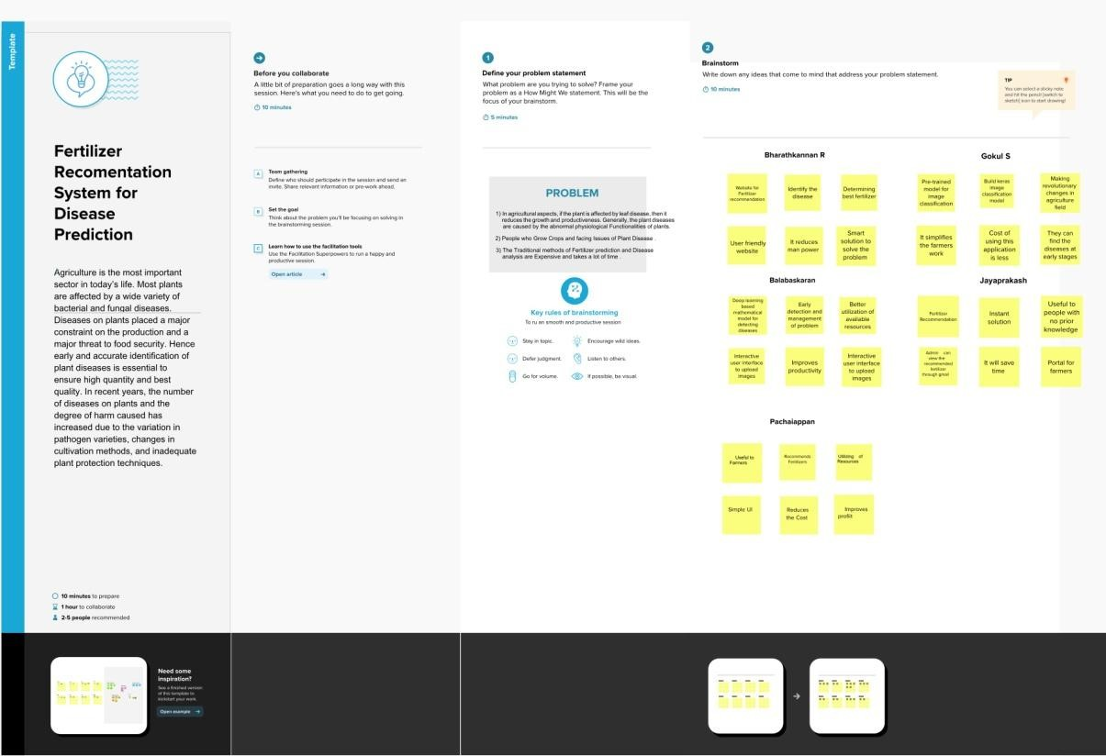

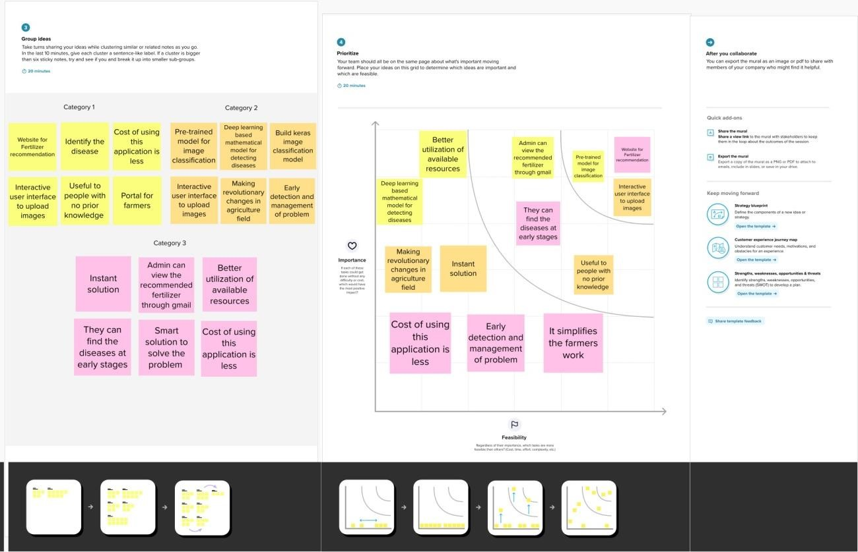

**Empathy Map Canvas :**

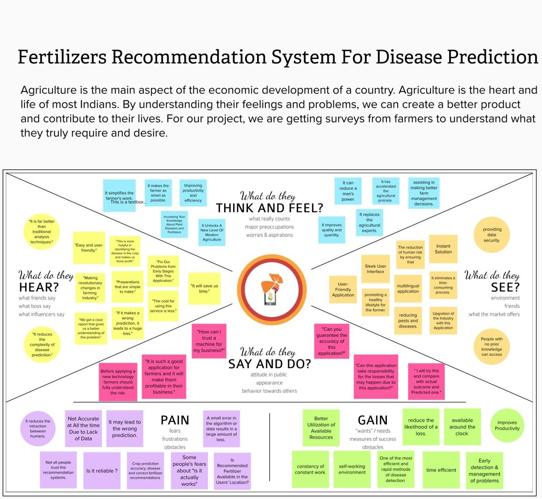

**Proposed Solution :**

* + The idea of the proposed solution uses Deep learning and Machine algorithm to classify leaves and identify the diseases and siggest the fertilizers. The deep learning process includes the MobileNetV2 and VGG19 training Models.

* + Based on the leaf disease detected , the model recommendation for fertilizers for the prevention. The farmers and researchers are the end users get benefied by the system.

* + More accurate in others. The system is more robust corporating more image data sets with wider variations. This system also estimates the probability of infected plant.
  + Plant growth can be enhanced. Ensure plants are getting supplied with every nutrient they need also and multiple cross in grow in every yields for every season. It also helps people's nutritional needs.

**Problem Solution Fit**

* + 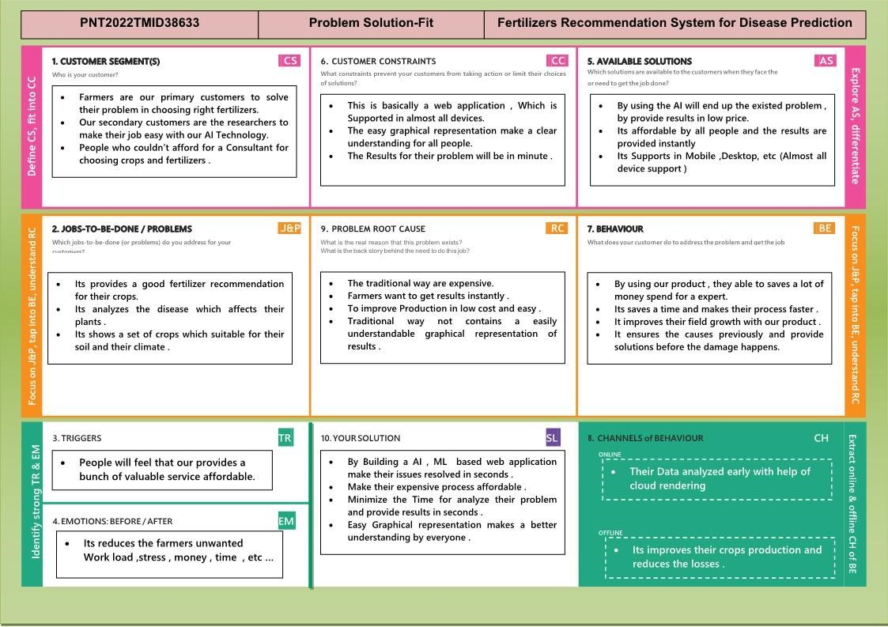This Learn and Build phase has proven to be the most important, parallel phase that successful startups follow. It contains the very first activity that startups should follow if they have an idea: Find prospective customers to talk to. Usually, this idea is already translated to a software product, which should always be a Minimum Viable Product (MVP) a version of the product that requires the least amount of development time with a minimum amount of effort.

* + An MVP is based on requirements desired by potential customers, but to obtain these requirements, the startup should talk as early as possible with those customers. The startup then requires to prioritise the ‘must haves’, which are the minimum necessary requirements for the MVP. Once the MVP is ready for customer feedback, the second most important activity is performed by the startup foreveryone.

**REQUIREMENT ANALYSIS :**

## Functional Requirements

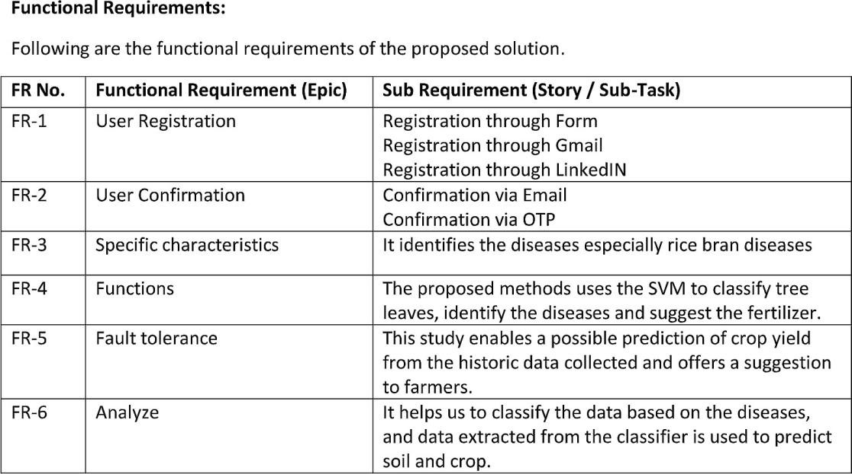

## Non Functional Requirements

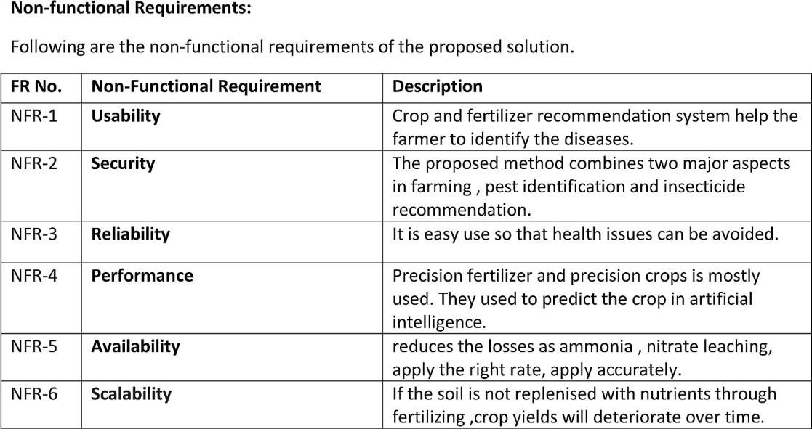

**PROJECT DESIGN :**

## Solution & Technical Architecture

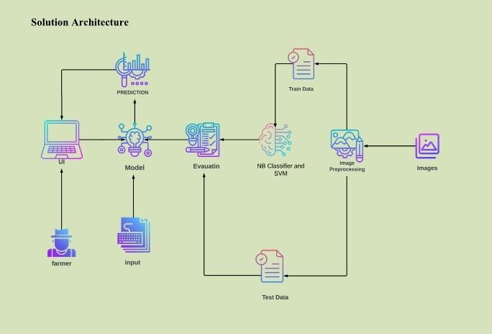

## Data Flow Diagrams

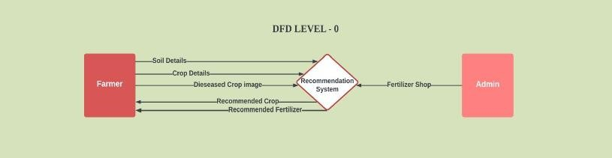

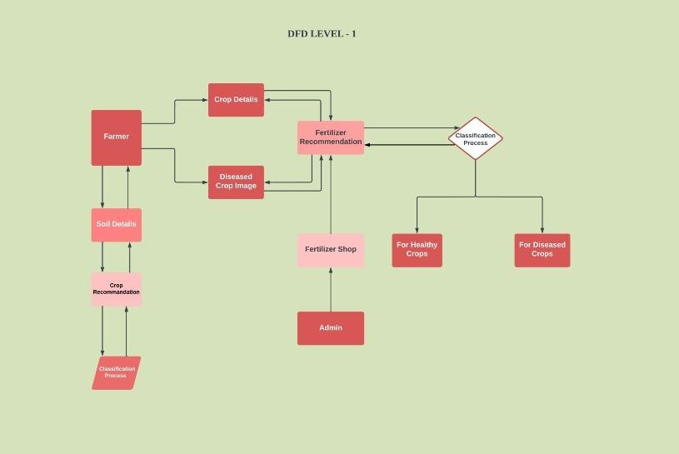

## User Stories

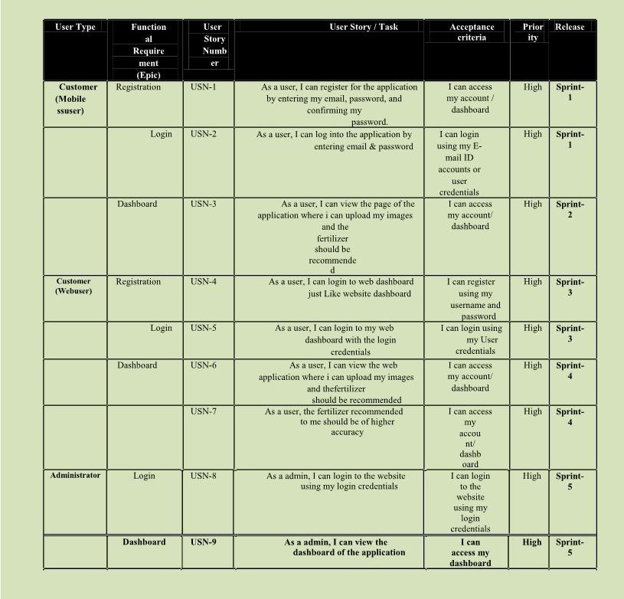

**PROJECT PLANNING & SCHEDULING :**

## Sprint Planning and Estimation

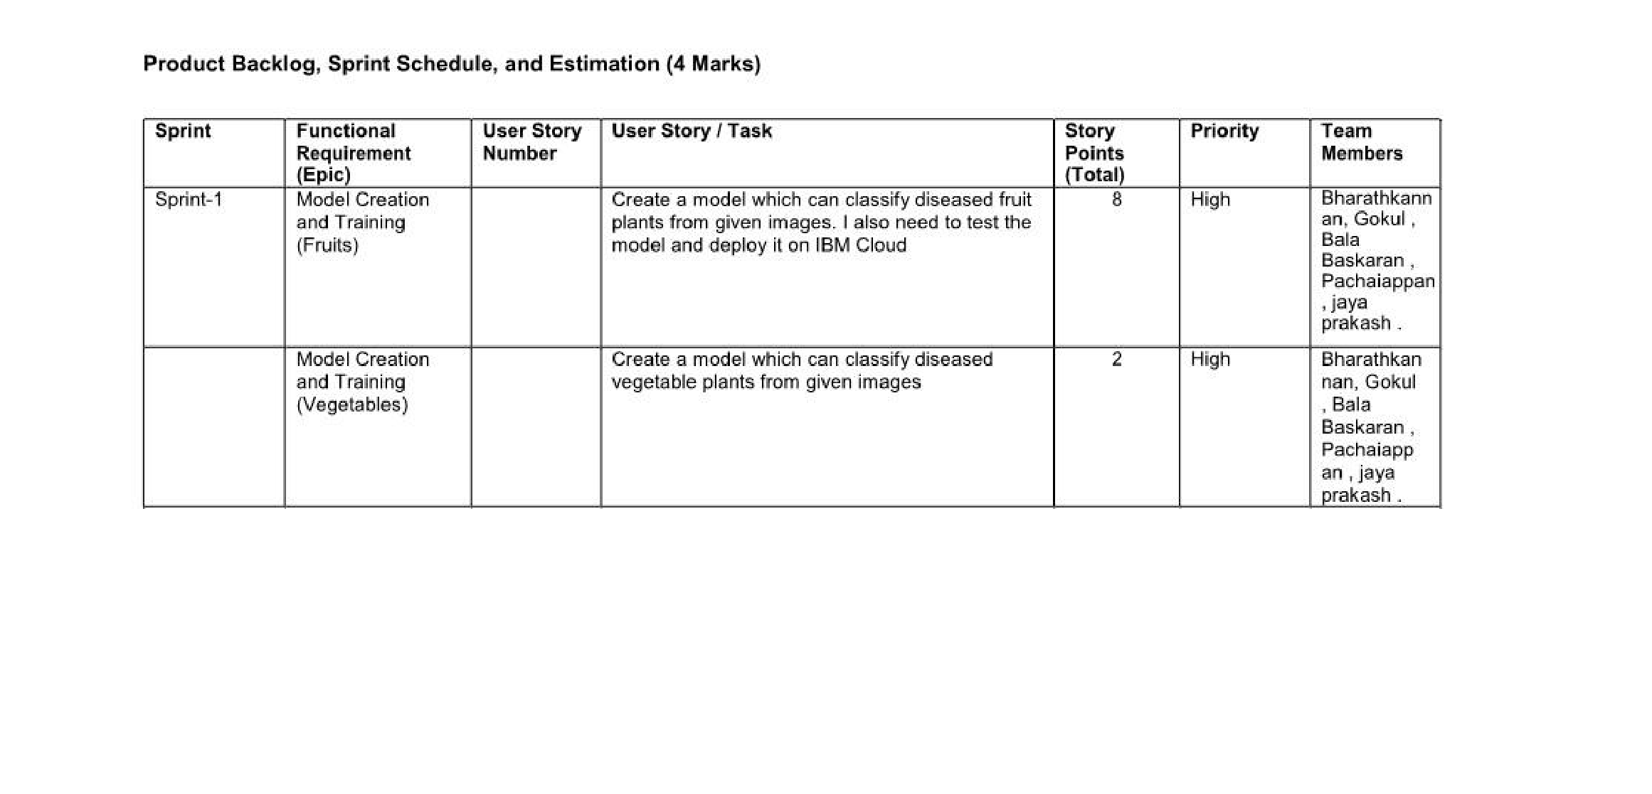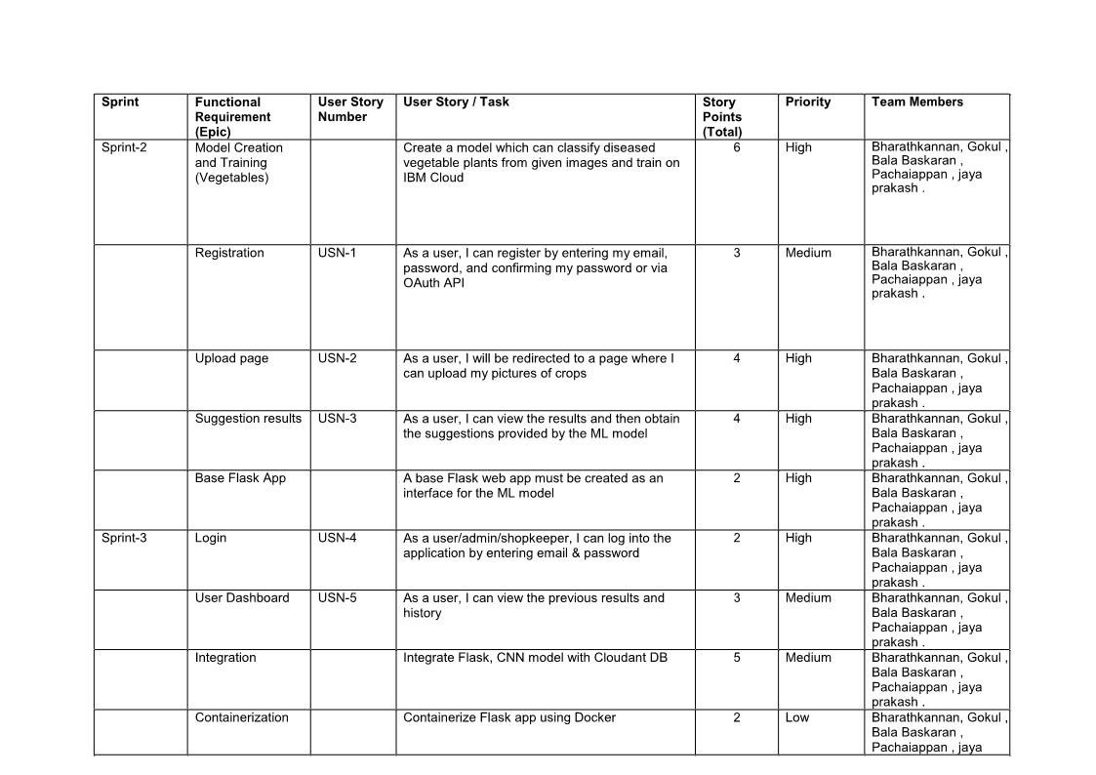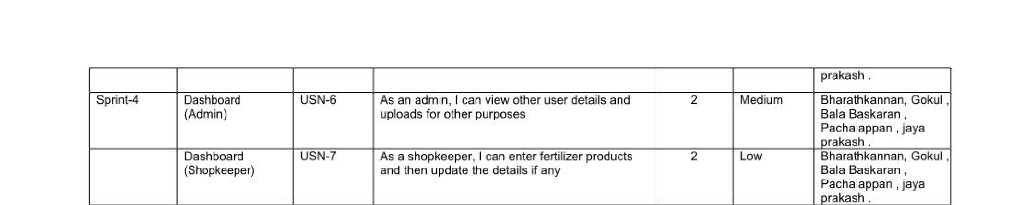

## Sprint Delivery Schedule

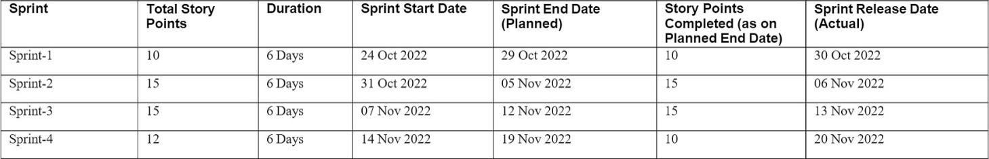

### Reports from JIRA



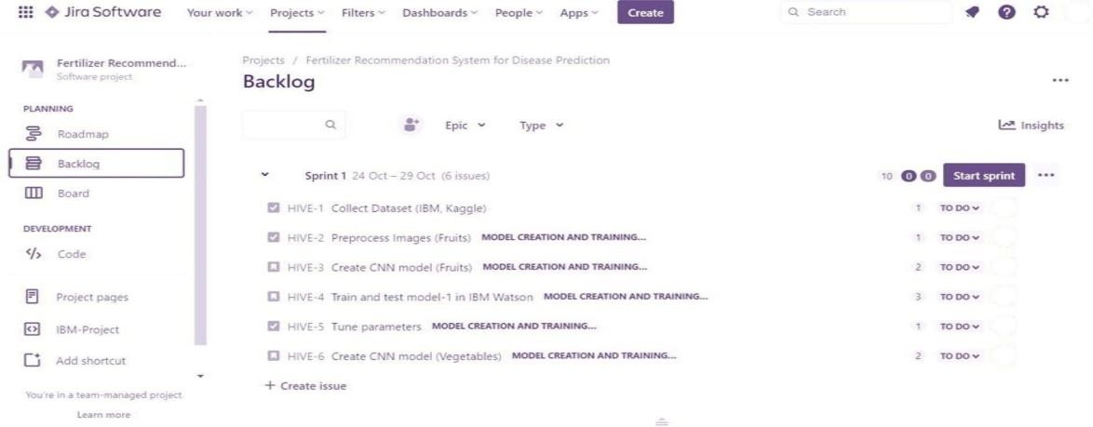

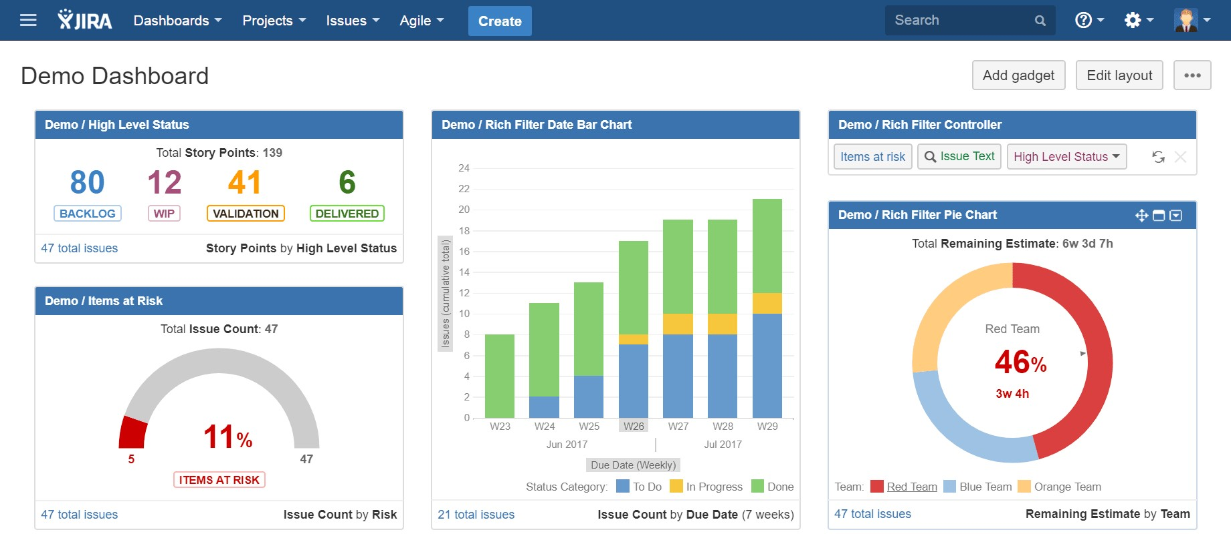

**Feature 1[Model Building]:**

1. **Import The Libraries**

Import the libraries that are required to initialize the neural network layer, and create and add different layers to the neural network model.

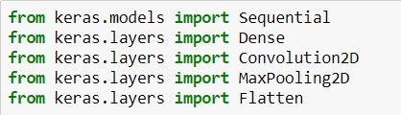

1. **Initializing The Model** Keras has 2 ways to define a neural network:
   * Sequential
   * Function API

The Sequential class is used to define linear initializations of network layers which then, collectively, constitute a model. In our example below, we will use the Sequential constructor to create a model, which will then have layers added to it using the add () method. Now, will initialize our model.

Initialize the neural network layer by creating a reference/object to the Sequential class.



### 3. ADD CNNLayers

We will be adding three layers for CNN

* Convolution layer
* Pooling layer ● Flattening layer

### Add Convolution Layer

The first layer of the neural network model, the convolution layer will be added. To create a convolution layer, Convolution2D class is used. It takes a number of feature detectors, feature detector size, expected input shape of the image, and activation function as arguments. This layer applies feature detectors on the input image and returns a feature map (features from the image).

Activation Function: These are the functions that help us to decide if we need to activate the node or not. These functions introduce non-linearity in the networks.



### Add the pooling layer

Max Pooling selects the maximum element from the region of the feature map covered by the filter. Thus, the output after the max-pooling layer would be a feature map containing the most prominent features of the previous feature map.

After the convolution layer, a pooling layer is added. Max pooling layer can be added using

MaxPooling2D class. It takes the pool size as a parameter. Efficient size of the pooling matrix is (2,2). It returns the pooled feature maps. (Note: Any number of convolution layers, pooling and dropout layers can be added)



### Add the flatten layer

The flatten layer is used to convert n-dimensional arrays to 1-dimensional arrays. This 1D array will be given as input to ANN layers.



**4. Add Dense Layers**

Now, let's add Dense Layers to know more about dense layers click below

[**Dense layers**](https://machinelearningknowledge.ai/keras-dense-layer-explained-for-beginners/)

The name suggests that layers are fully connected (dense) by the neurons in a network layer. Each neuron in a layer receives input from all the neurons present in the previous layer. Dense is used to add the layers.

### Adding Hidden layers

This step is to add a dense layer (hidden layer). We flatten the feature map and convert it into a vector or single dimensional array in the Flatten layer. This vector array is fed it as an input to the neural network and applies an activation function, such as sigmoid or other, and returns the output.

* init is the weight initialization; function which sets all the weights and biases of a network to values suitable as a starting point for training.
* units/ output_dim, which denote is the number of neurons in the hidden layer.
* The activation function basically decides to deactivate neurons or activate them to get the desired output. It also performs a nonlinear transformation on the input to get better results on a complex neural network.
* You can add many hidden layers, in our project we are added two hidden layers. The 1st hidden layer with 40 neurons and 2nd hidden layer with 20neurons.

### Adding the output layer

This step is to add a dense layer (output layer) where you will be specifying the number of classes your dependent variable has, activation function, and weight initializer as the arguments. We use the add () method to add dense layers. the output dimensions here is 6

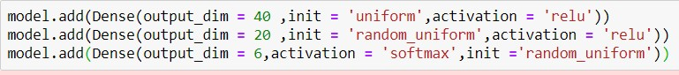

**5. Train And Save The Model Compile the model**

After adding all the required layers, the model is to be compiled. For this step, loss function, optimizer and metrics for evaluation can be passed as arguments.



### Fit and save the model

Fit the neural network model with the train and test set, number of epochs and validation steps. Steps per epoch is determined by number of training images/ batch size, for validation steps number of validation images/ batch size.



Accuracy, Loss: Loss value implies how poorly or well a model behaves after each iteration of optimization. An accuracy metric is used to measure the algorithm's performance in an interpretable way. The accuracy of a model is usually determined after the model parameters and is calculated in the form of a percentage. The weights are to be saved for future use. The weights are saved in as .h5 file using save().

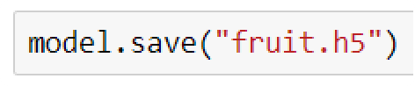

**model.summary()** can be used to see all parameters and shapes in each layer in our models.

**6. Test The Model**

The model is to be tested with different images to know if it is working correctly.

### Import the packages and load the saved model

Import the required libraries

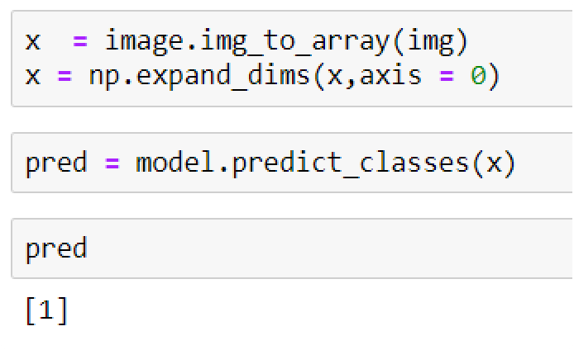

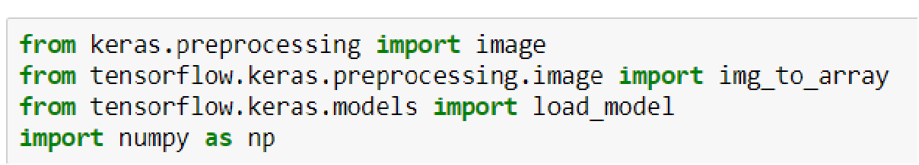

Initially, we will be loading the fruit model. You can test it with the vegetable model in a similar way.

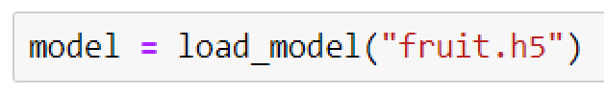

Load the test image, pre-process it and predict

Pre-processing the image includes converting the image to array and resizing according to the model. Give the pre-processed image to the model to know to which class your model belongs to.

**The predicted class is 1.**

**Feature 2[Python Code]:**

**Build Python Code:**

After the model is built, we will be integrating it into a web application so that normal users can also use it. The user needs to browse the images to detect the disease.

**Activity 1:** Build a flask application

**Step 1:** Load the required packages

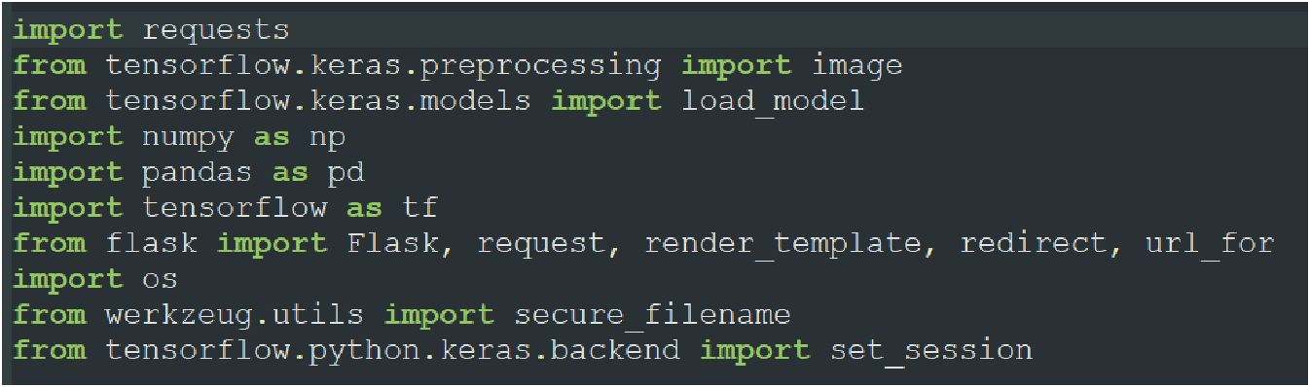

**Step 2:** Initialize the flask app and load the model

An instance of Flask is created and the model is loaded using load_model from Keras.

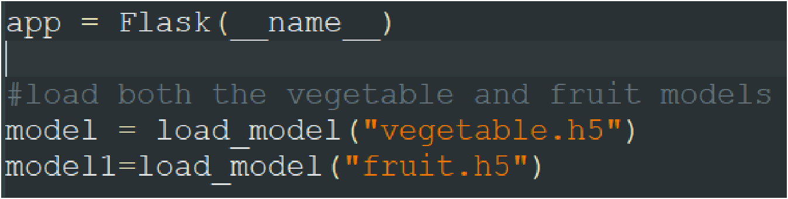

**Step 3:** Configure the home page

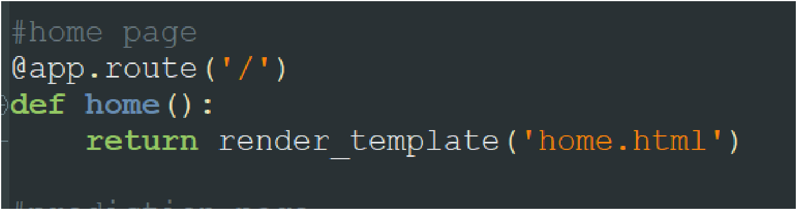

**Step 4:** Pre-process the frame and run

Pre-process the captured frame and give it to the model for prediction. Based on the prediction the output text is generated and sent to the HTML to display. We will be loading the precautions for fruits and vegetables excel file to get the precautions based on the output and return it to the HTML Page.

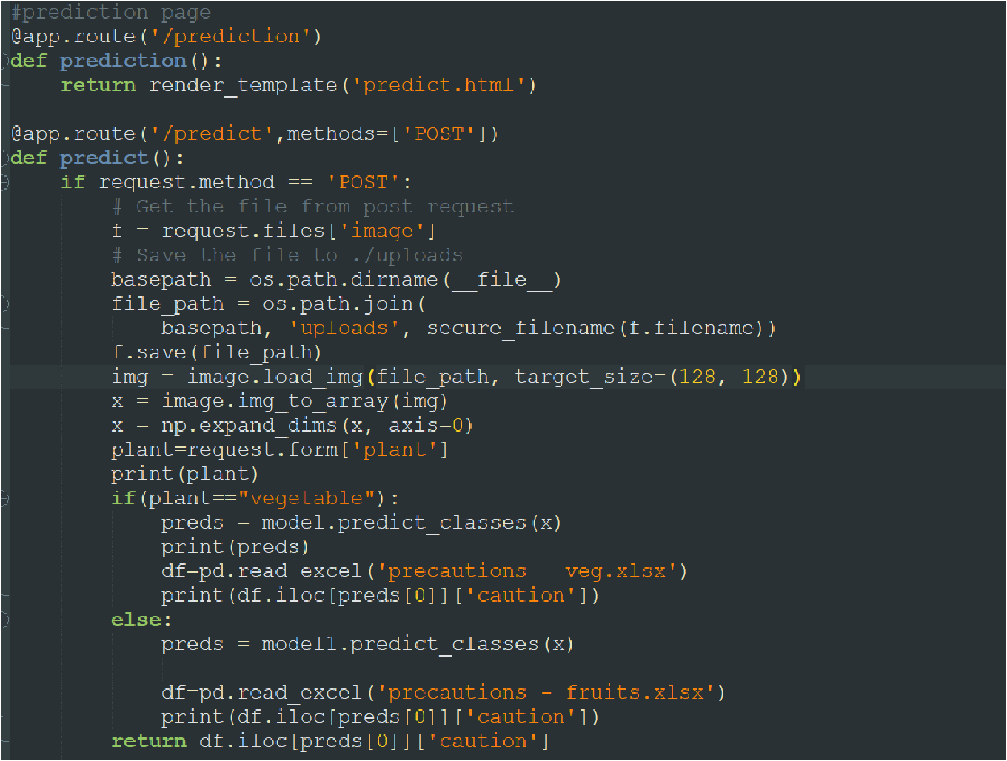

Run the flask application using the run method. By default, the flask runs on 5000 port. If the port is to be changed, an argument can be passed and the port can be modified.

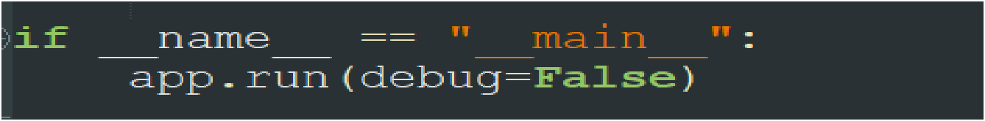

**TESTING**

## TEST CASES 1

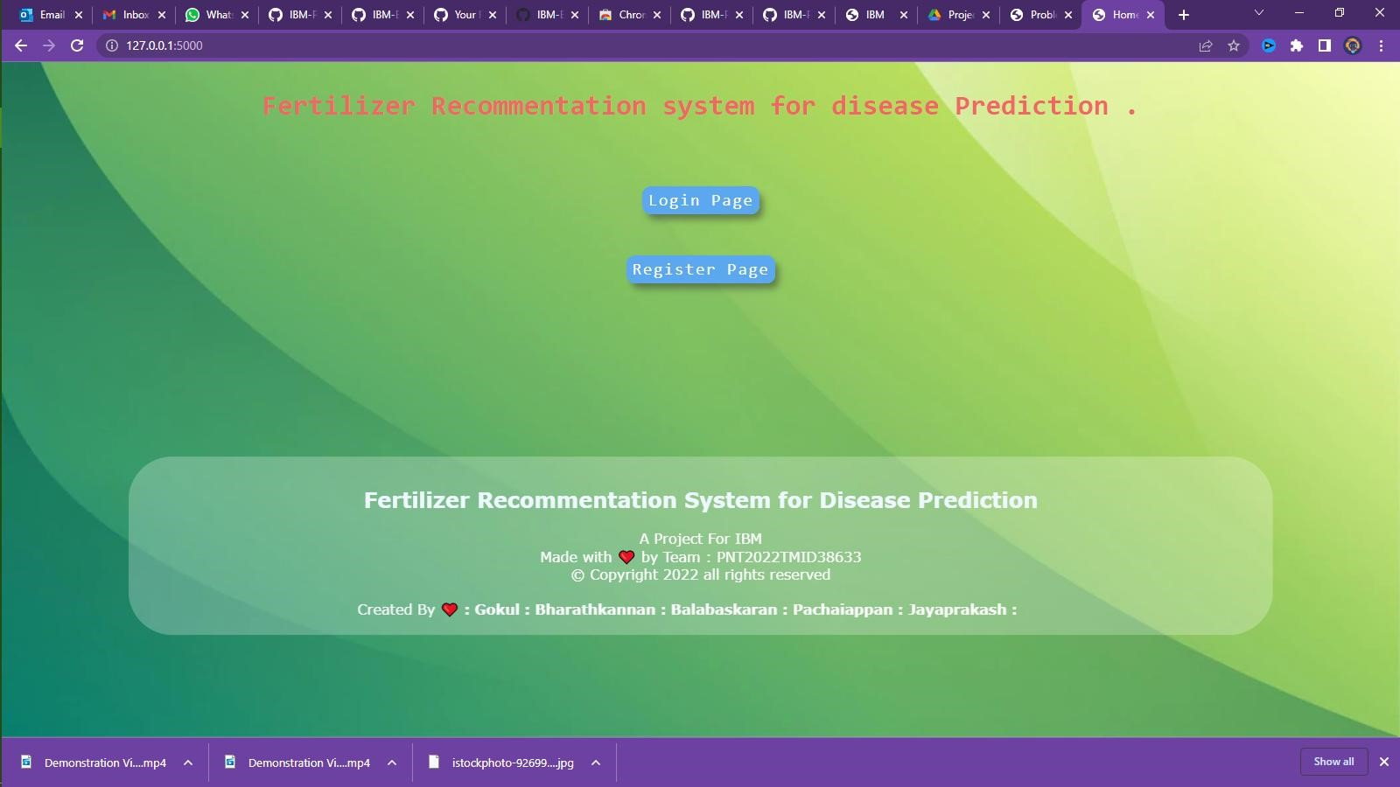

## TEST CASES 2

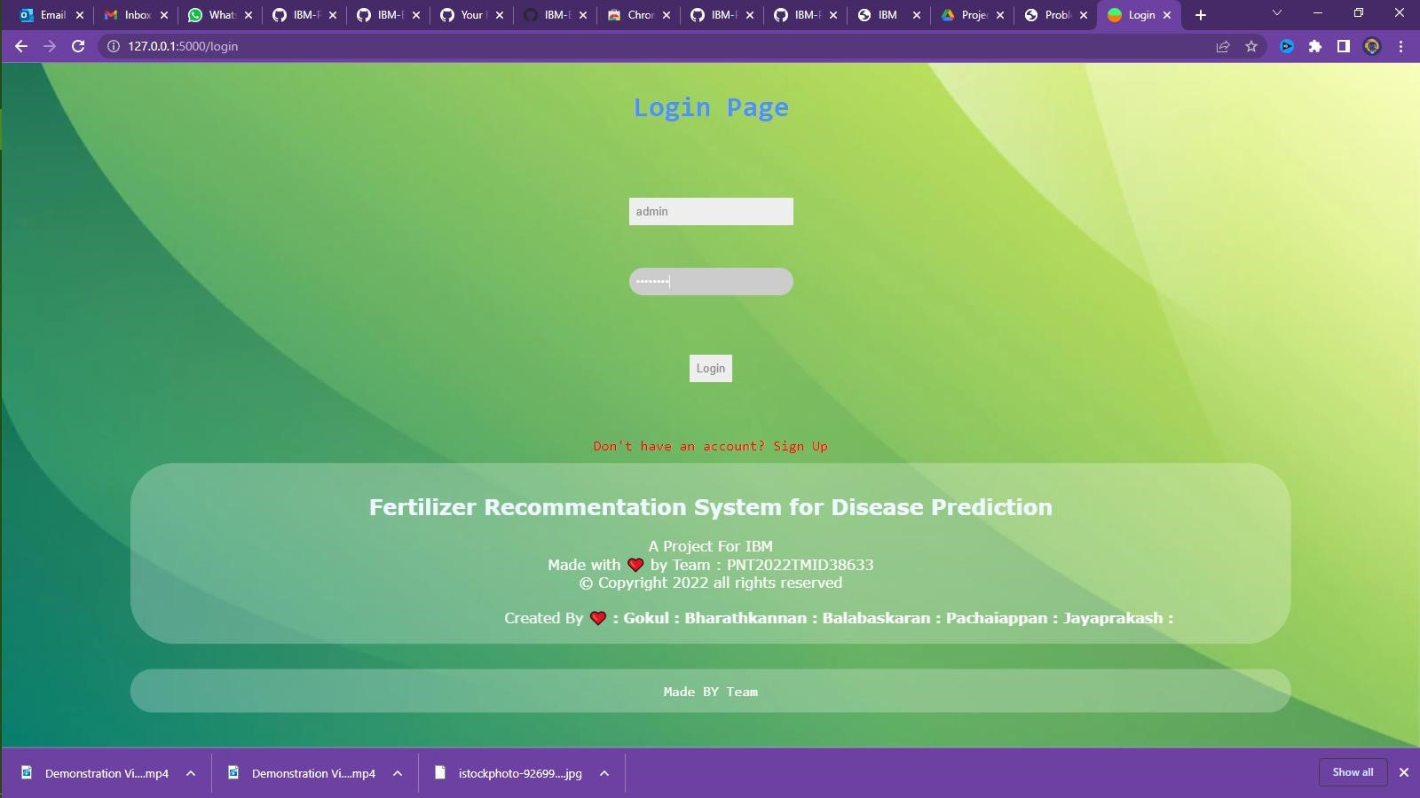

## TEST CASES 3

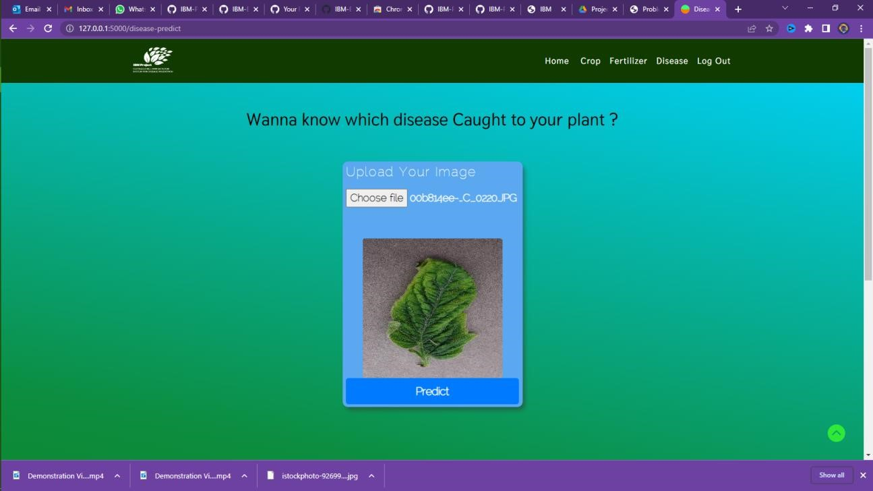

## TEST CASES 4



## TEST CASES 5

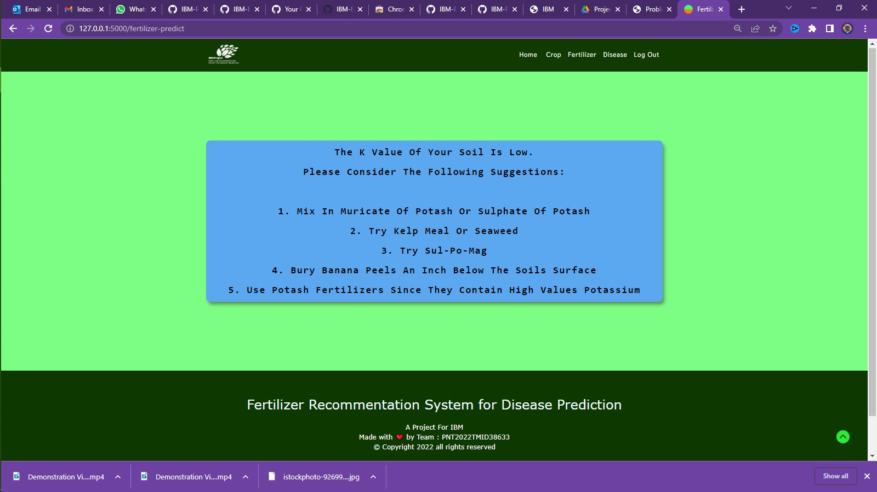

**User Acceptance Testing:**

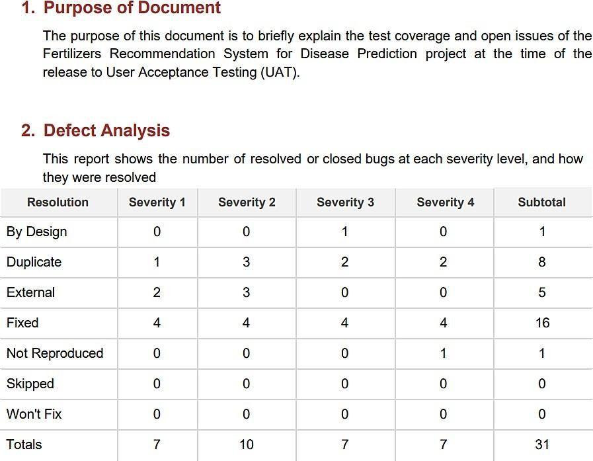

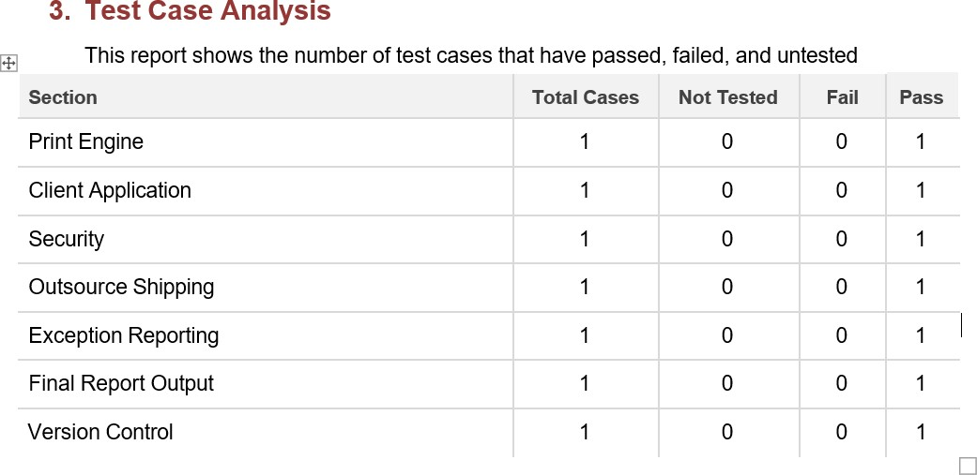

**RESULTS: Performance Metrics:**

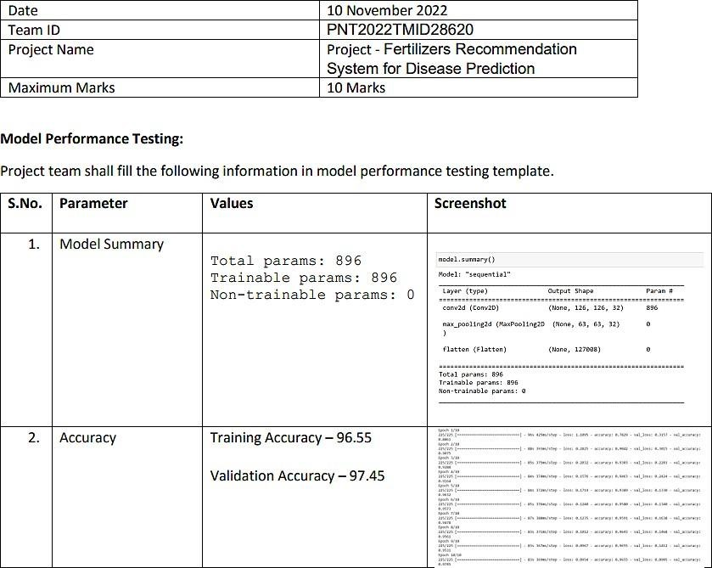

**Model Summary:**

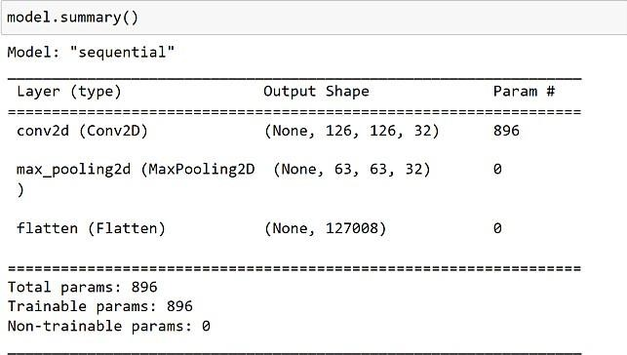

**Accuracy:**

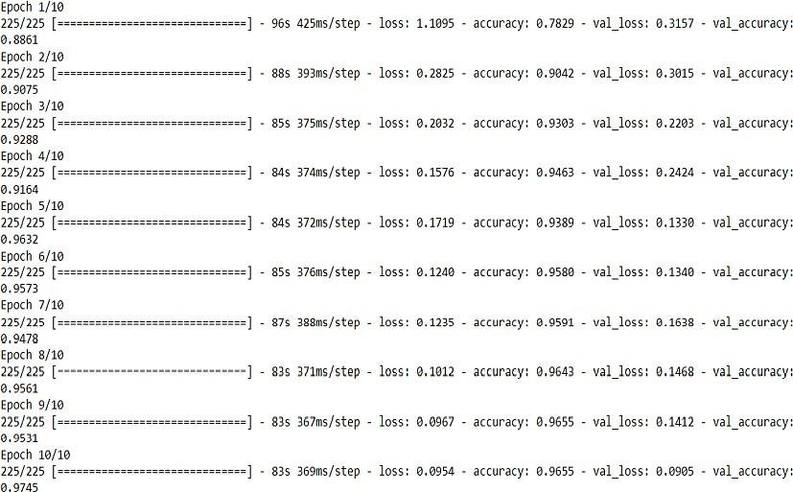

**Locust report:**

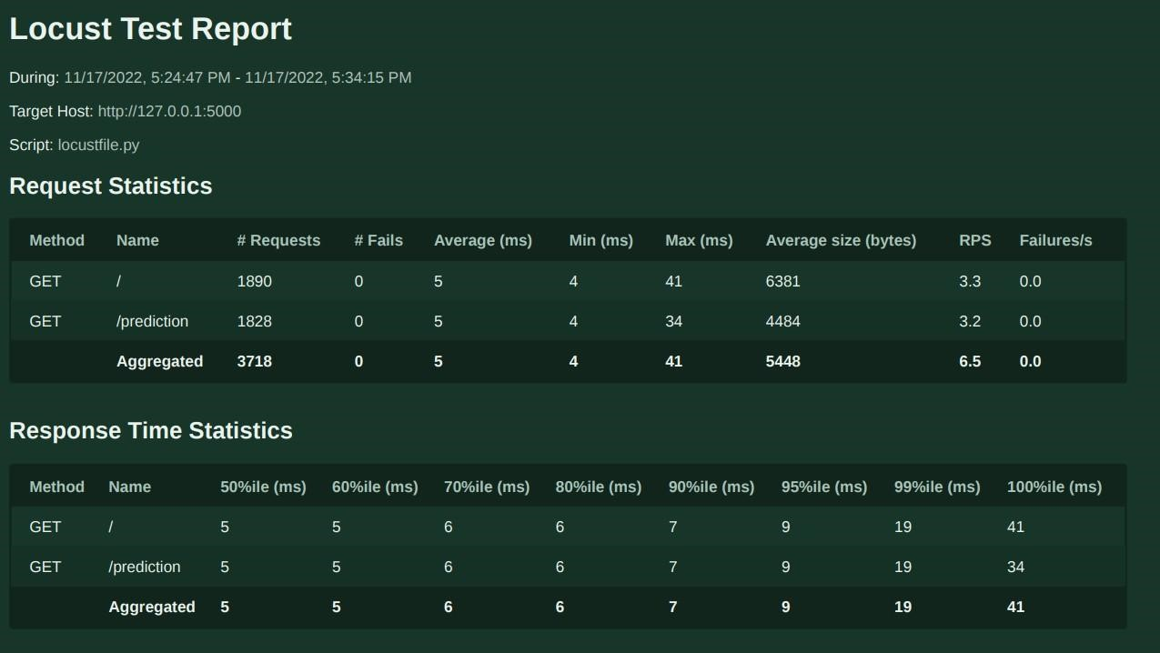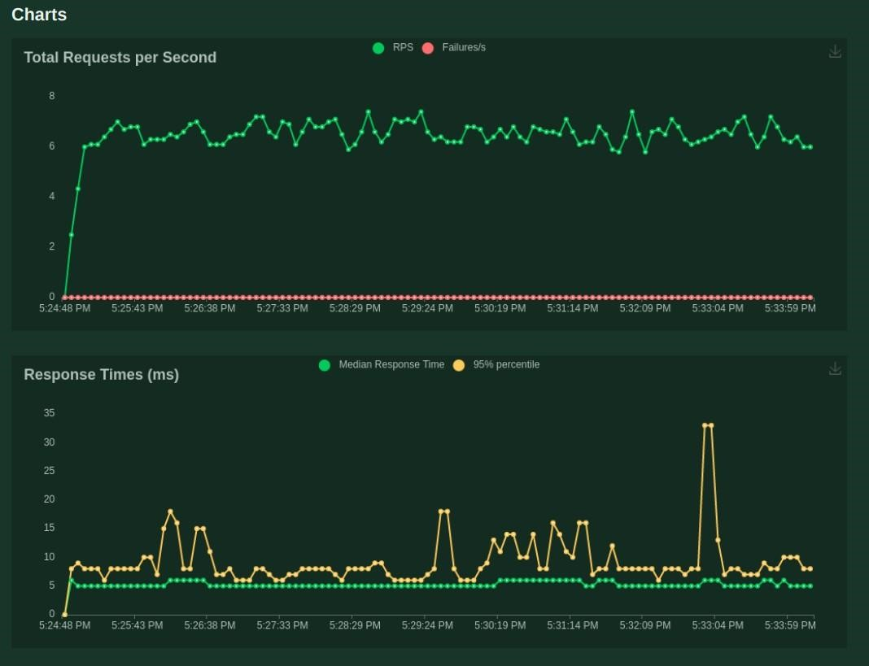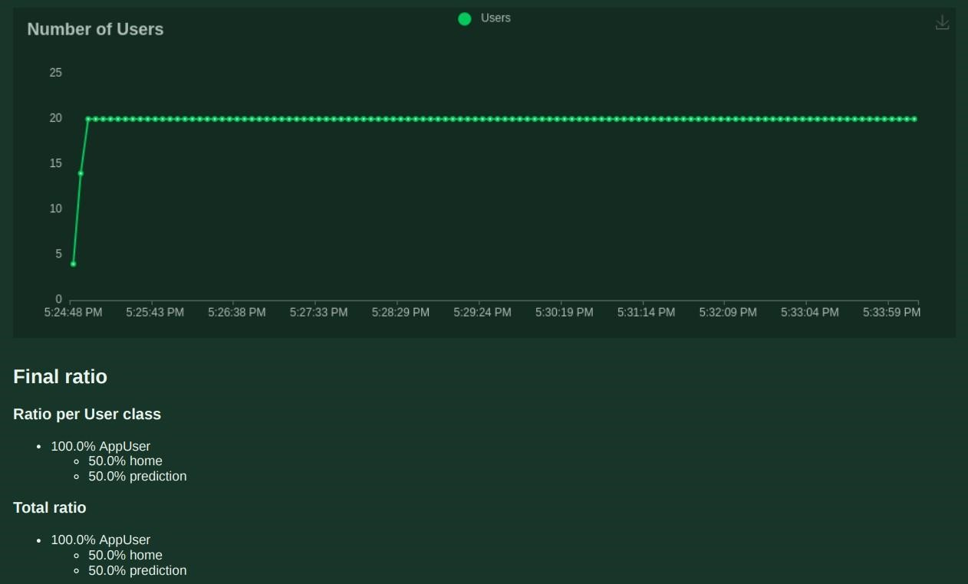

**ADVANTAGES & DISADVANTAGES:**

**ADVANTAGES:**

➤ The proposed model could predict the disease just from the image of a part icular plant.

➤ Easy to use UI.

➤ Model has some good accuracy in detecting the plant just by taking the **input(leaf).**

➤ These kind of web applications can be used in the agricultural sector as well as for small house hold plants as well.

**Disadvantages:**

➤ Prediction is limited to few plants as we havent trained all the plants.

**Conclusion :**

**●** The core strategy of this project is to predict the crop based on the soil nutrient content and the location where the crop is growing. This system will help he farmers to choose the right crop for their land and to give the suitable amount of fertilizer to produce the maximum yield. The Support Vector Machine algorithm helps to predict the crop the precisely based on the pre-processed crop data. This system will also help the new comers to choose the crop which will grow in their area and produce them a good profit. A decent amount of profit will attract more people towards the agriculture.

**Future Scope :**

* As of now we have just built the web application which apparently takes the input as an image and then predict the out in the near future we can develop an application which computer vision and AI techniques to predict the infection once you keep the camera near the plant or leaf this could make our project even more usable

* This further research is implementing the proposed algorithm with the existing public datasets. Also, various segmentation algorithms can be implemented to improve accuracy. The proposed algorithm can be modified further to identify the disease that affects the various plant organs such as vegetables and fruits.

**Appendix :**

**Requirement.txt**

numpy pandas Flask scikit-learn

https://download.pytorch.org/whl/cpu/torch-1.7.0%2Bcpu-cp36-cp36m-linux_x86_64.whl https://download.pytorch.org/whl/cpu/torchvision-0.8.1%2Bcpu-cp36-cp36m-linux_x86_64.whl requests Pillow gunicorn == 20.0.4 asgiref==3.5.0 bcrypt==3.2.0 cffi==1.15.0 click==8.1.2 dnspython==2.2.1 email-validator==1.1.3 Flask==2.1.1

Flask-Bcrypt==1.0.1

Flask-Login==0.6.0

Flask-SQLAlchemy==2.5.1 Flask-WTF==1.0.1 greenlet==1.1.2 idna==3.3 importlib-metadata==4.11.3 itsdangerous==2.1.2 Jinja2==3.1.1 MarkupSafe==2.1.1 pycparser==2.21 six==1.16.0

SQLAlchemy==1.4.35 sqlparse==0.4.2 Werkzeug==2.1.1 WTForms==3.0.1 zipp==3.8.0 flask_sqlalchemy flask_login flask_wtf wtforms wtforms.validators flask_bcrypt

**App.py**

# Importing essential libraries and modules

from flask import Flask, render_template, request, Markup,url_for, redirect import numpy as np import pandas as pd from utils.disease import disease_dic from utils.fertilizer import fertilizer_dic

import requests import config import pickle import io import torch

from torchvision import transforms from PIL import Image from utils.model import ResNet9 from flask_sqlalchemy import SQLAlchemy

from flask_login import UserMixin, login_user, LoginManager, login_required, logout_user, current_user from flask_wtf import FlaskForm

from wtforms import StringField, PasswordField, SubmitField from wtforms.validators import InputRequired, Length, ValidationError from flask_bcrypt import Bcrypt

#

======================================================================================== ======

# -------------------------LOADING THE TRAINED MODELS -----------------------------------------------

# Loading plant disease classification model

disease_classes = ['Apple___Apple_scab',

'Apple___Black_rot',

'Apple___Cedar_apple_rust',

'Apple___healthy',

'Blueberry___healthy',

'Cherry_(including_sour)___Powdery_mildew',

'Cherry_(including_sour)___healthy',

'Corn_(maize)___Cercospora_leaf_spot Gray_leaf_spot',

'Corn_(maize)___Common_rust_',

'Corn_(maize)___Northern_Leaf_Blight',

'Corn_(maize)___healthy',

'Grape___Black_rot',

'Grape___Esca_(Black_Measles)',

'Grape___Leaf_blight_(Isariopsis_Leaf_Spot)', 'Grape___healthy',

'Orange___Haunglongbing_(Citrus_greening)',

'Peach___Bacterial_spot',

'Peach___healthy',

'Pepper,_bell___Bacterial_spot',

'Pepper,_bell___healthy',

'Potato___Early_blight',

'Potato___Late_blight',

'Potato___healthy',

'Raspberry___healthy',

'Soybean___healthy',

'Squash___Powdery_mildew',

'Strawberry___Leaf_scorch',

'Strawberry___healthy',

'Tomato___Bacterial_spot',

'Tomato___Early_blight',

'Tomato___Late_blight',

'Tomato___Leaf_Mold',

'Tomato___Septoria_leaf_spot',

'Tomato___Spider_mites Two-spotted_spider_mite',

'Tomato___Target_Spot',

'Tomato___Tomato_Yellow_Leaf_Curl_Virus',

'Tomato___Tomato_mosaic_virus',

'Tomato___healthy']

disease_model_path = 'models/plant_disease_model.pth' disease_model = ResNet9(3, len(disease_classes)) disease_model.load_state_dict(torch.load(

disease_model_path, map_location=torch.device('cpu'))) disease_model.eval()

# Loading crop recommendation model

crop_recommendation_model_path = 'models/RandomForest.pkl' crop_recommendation_model = pickle.load( open(crop_recommendation_model_path, 'rb'))

#

========================================================================================

=

# Custom functions for calculations

def weather_fetch(city_name):

"""

Fetch and returns the temperature and humidity of a city

:params: city_name

:return: temperature, humidity

"""

api_key = config.weather_api_key

base_url = "http://api.openweathermap.org/data/2.5/weather?"

complete_url = base_url + "appid=" + api_key + "&q=" + city_name response = requests.get(complete_url) x = response.json()

if x["cod"] != "404":

y = x["main"]

temperature = round((y["temp"] - 273.15), 2) humidity = y["humidity"]

return temperature, humidity else: return None

def predict_image(img, model=disease_model):

"""

Transforms image to tensor and predicts disease label

:params: image

:return: prediction (string)

"""

transform = transforms.Compose([

transforms.Resize(256),

transforms.ToTensor(),

])

image = Image.open(io.BytesIO(img)) img_t = transform(image)

img_u = torch.unsqueeze(img_t, 0)

# Get predictions from model yb = model(img_u)

# Pick index with highest probability _, preds = torch.max(yb, dim=1)

prediction = disease_classes[preds[0].item()]

# Retrieve the class label return prediction

#

======================================================================================== =======

# ------------------------------------ FLASK APP -------------------------------------------------

app = Flask(__name__)

db = SQLAlchemy(app) bcrypt = Bcrypt(app)

app.config['SQLALCHEMY_DATABASE_URI'] = 'sqlite:///database.db' app.config['SECRET_KEY'] = 'thisisasecretkey'

login_manager = LoginManager() login_manager.init_app(app)

login_manager.login_view = 'login'

@login_manager.user_loader def load_user(user_id):

return User.query.get(int(user_id))

class User(db.Model, UserMixin):

id = db.Column(db.Integer, primary_key=True)

username = db.Column(db.String(20), nullable=False, unique=True) password = db.Column(db.String(80), nullable=False)

class RegisterForm(FlaskForm):

username = StringField(validators=[

InputRequired(), Length(min=4, max=20)], render_kw={"placeholder": "Username"})

password = PasswordField(validators=[

InputRequired(), Length(min=8, max=20)], render_kw={"placeholder": "Password"}) submit = SubmitField('Register')

def validate_username(self, username): existing_user_username = User.query.filter_by( username=username.data).first() if existing_user_username: raise ValidationError(

'That username already exists. Please choose a different one.')

class LoginForm(FlaskForm):

username = StringField(validators=[

InputRequired(), Length(min=4, max=20)], render_kw={"placeholder": "Username"})

password = PasswordField(validators=[

InputRequired(), Length(min=8, max=20)], render_kw={"placeholder": "Password"})

submit = SubmitField('Login')

@app.route('/') def home(): return render_template('home.html')

@app.route('/login', methods=['GET', 'POST']) def login():

form = LoginForm() if form.validate_on_submit(): user = User.query.filter_by(username=form.username.data).first() if user: if bcrypt.check_password_hash(user.password, form.password.data): login_user(user) return redirect (url_for('dashboard')) return render_template('login.html', form=form)

@app.route('/dashboard', methods=['GET', 'POST'])

@login_required def dashboard():

return render_template('dashboard.html')

@app.route('/logout', methods=['GET', 'POST'])

@login_required def logout(): logout_user()

return redirect(url_for('login'))

@ app.route('/register', methods=['GET', 'POST']) def register():

form = RegisterForm()

if form.validate_on_submit():

hashed_password = bcrypt.generate_password_hash(form.password.data)

new_user = User(username=form.username.data, password=hashed_password) db.session.add(new_user) db.session.commit() return redirect(url_for('login')) return render_template('register.html', form=form)

# render home page

# render crop recommendation form page

@ app.route('/crop-recommend') def crop_recommend():

title = 'Crop Recommendation'

return render_template('crop.html', title=title)

# render fertilizer recommendation form page

@ app.route('/fertilizer') def fertilizer_recommendation(): title = 'Fertilizer Suggestion'

return render_template('fertilizer.html', title=title)

# render disease prediction input page

#

======================================================================================== =======

# RENDER PREDICTION PAGES

# render crop recommendation result page

@ app.route('/crop-predict', methods=['POST']) def crop_prediction():

title = 'Crop Recommendation'

if request.method == 'POST': N = int(request.form['nitrogen'])

P = int(request.form['phosphorous']) K = int(request.form['pottasium']) ph = float(request.form['ph'])

rainfall = float(request.form['rainfall'])

# state = request.form.get("stt") city = request.form.get("city")

if weather_fetch(city) != None:

temperature, humidity = weather_fetch(city) data = np.array([[N, P, K, temperature, humidity, ph, rainfall]]) my_prediction = crop_recommendation_model.predict(data)

final_prediction = my_prediction[0] return render_template('crop-result.html', prediction=final_prediction, title=title)

else:

return render_template('try_again.html', title=title)

# render fertilizer recommendation result page

@ app.route('/fertilizer-predict', methods=['POST']) def fert_recommend():

title = 'Fertilizer Suggestion'

crop_name = str(request.form['cropname'])

N = int(request.form['nitrogen'])

P = int(request.form['phosphorous'])

K = int(request.form['pottasium'])

# ph = float(request.form['ph'])

df = pd.read_csv('Data/fertilizer.csv')

nr = df[df['Crop'] == crop_name]['N'].iloc[0] pr = df[df['Crop'] == crop_name]['P'].iloc[0] kr = df[df['Crop'] == crop_name]['K'].iloc[0]

n = nr - N p = pr - P k = kr - K temp = {abs(n): "N", abs(p): "P", abs(k): "K"} max_value = temp[max(temp.keys())] if max_value == "N": if n < 0:

key = 'NHigh' else:

key = "Nlow" elif max_value == "P": if p < 0:

key = 'PHigh' else: key = "Plow" else: if k < 0:

key = 'KHigh' else:

key = "Klow"

response = Markup(str(fertilizer_dic[key]))

return render_template('fertilizer-result.html', recommendation=response, title=title)

# render disease prediction result page

@app.route('/disease-predict', methods=['GET', 'POST'])

def disease_prediction():

title = 'Disease Detection'

if request.method == 'POST': if 'file' not in request.files: return redirect(request.url) file = request.files.get('file') if not file:

return render_template('disease.html', title=title) try:

img = file.read()

prediction = predict_image(img)

prediction = Markup(str(disease_dic[prediction])) return render_template('disease-result.html', prediction=prediction, title=title) except: pass

return render_template('disease.html', title=title)

#

========================================================================================

=======

if __name__ == '__main__': app.run(debug=True)

**Notebook Code( ipynb File ) :**

# Creating final data for crop and fertilizer recommendation system import pandas as pd

import matplotlib.pyplot as plt import seaborn as sns

fertilizer_data_path = '../Data-raw/FertilizerData.csv' merge_fert = pd.read_csv(fertilizer_data_path) merge_fert.head() del merge_fert['Unnamed: 0'] merge_fert.describe() merge_fert['Crop'].unique() plt.plot(merge_fert["N"]) plt.plot(merge_fert["P"]) plt.plot(merge_fert["K"])

sns.heatmap(merge_fert.corr(),annot=True)

merge_crop = pd.read_csv('../Data-raw/MergeFileCrop.csv') reco_fert = merge_fert #Add +/-3 for every NPK value import random

temp = pd.DataFrame(columns = ['N','P','K']) for i in range(0,merge_crop.shape[0]): crop = merge_crop.label.iloc[i]

#print(crop)

N = reco_fert[reco_fert['Crop'] == crop]["N"].iloc[0] + random.randint(-20,20)

P = reco_fert[reco_fert['Crop'] == crop]["P"].iloc[0] + random.randint(-5,20)

K = reco_fert[reco_fert['Crop'] == crop]["K"].iloc[0] + random.randint(-5,5) d = {"N":N,"P":P,"K":K}

#print(d)

temp = temp.append(d,ignore_index = True) temp merge_crop['N'] = temp['N'] merge_crop['P'] = temp['P'] merge_crop['K'] = temp['K'] merge_crop

del merge_crop['Unnamed: 0'] merge_crop

merge_crop = merge_crop[[ 'N', 'P', 'K','temperature', 'humidity', 'ph', 'rainfall', 'label']] merge_crop.to_csv("../Data-processed/crop_recommendation.csv",index=False)

# Checking if everything went fine

df = pd.read_csv('../Data-processed/crop_recommendation.csv') df.head() df.shape

# ☘☘ PLANT DISEASE CLASSIFICATION USING RESNET-9 ☘☘

### Corresponding Kaggle notebook can be accessed [here](https://www.kaggle.com/atharvaingle/plant-diseaseclassification-resnet-99-2)

##### ☘☘☘☘☘☘DISCLAIMER: This notebook is beginner friendly, so don't worry if you don't know much about CNNs and Pytorch. Even if you have used TensorFlow in the past and are new to PyTorch, hang in there, everything is explained clearly and concisely. You will get a good overview of how to use PyTorch for image classification problems. # Description of the dataset

This dataset is created using offline augmentation from the original dataset. The original PlantVillage

Dataset can be found [here](https://github.com/spMohanty/PlantVillage-Dataset).This dataset consists of about 87K rgb images of healthy and diseased crop leaves which is categorized into 38 different classes. The total dataset is divided into 80/20 ratio of training and validation set preserving the directory structure. A new directory containing 33 test images is created later for prediction purpose.

Note: This description is given in the dataset itself

# Our goal

Goal is clear and simple. We need to build a model, which can classify between healthy and diseased crop leaves and also if the crop have any disease, predict which disease is it.

##### Let's get started....

## Importing necessary libraries

Let's import required modules

!pip install torchsummary

We would require torchsummary library to print the model's summary in keras style (nicely formatted and pretty to look) as Pytorch natively doesn't support that import os # for working with files import numpy as np # for numerical computationss import pandas as pd # for working with dataframes import torch # Pytorch module

import matplotlib.pyplot as plt # for plotting informations on graph and images using tensors import torch.nn as nn # for creating neural networks from torch.utils.data import DataLoader # for dataloaders from PIL import Image # for checking images

import torch.nn.functional as F # for functions for calculating loss

import torchvision.transforms as transforms # for transforming images into tensors from torchvision.utils import make_grid # for data checking

from torchvision.datasets import ImageFolder # for working with classes and images from torchsummary import summary # for getting the summary of our model

%matplotlib inline

# Exploring the data Loading the data

data_dir = "../input/new-plant-diseases-dataset/New Plant Diseases Dataset(Augmented)/New Plant Diseases Dataset(Augmented)"

train_dir = data_dir + "/train" valid_dir = data_dir + "/valid" diseases = os.listdir(train_dir) # printing the disease names print(diseases)

print("Total disease classes are: {}".format(len(diseases))) plants = []

NumberOfDiseases = 0 for plant in diseases: if plant.split('___')[0] not in plants: plants.append(plant.split('___')[0]) if plant.split('___')[1] != 'healthy':

NumberOfDiseases += 1

The above cell extract the number of unique plants and number of unique diseases

# unique plants in the dataset

print(f"Unique Plants are: \n{plants}")

# number of unique plants

print("Number of plants: {}".format(len(plants)))

# number of unique diseases

print("Number of diseases: {}".format(NumberOfDiseases))

So we have images of leaves of 14 plants and while excluding healthy leaves, we have 26 types of images that show a particular disease in a particular plant.

# Number of images for each disease nums = {} for disease in diseases: nums[disease] = len(os.listdir(train_dir + '/' + disease))

# converting the nums dictionary to pandas dataframe passing index as plant name and number of images as column

img_per_class = pd.DataFrame(nums.values(), index=nums.keys(), columns=["no. of images"]) img_per_class

#### Visualizing the above information on a graph # plotting number of images available for each disease index = [n for n in range(38)] plt.figure(figsize=(20, 5))

plt.bar(index, [n for n in nums.values()], width=0.3) plt.xlabel('Plants/Diseases', fontsize=10) plt.ylabel('No of images available', fontsize=10) plt.xticks(index, diseases, fontsize=5, rotation=90) plt.title('Images per each class of plant disease')

We can see that the dataset is almost balanced for all classes, so we are good to go forward

#### Images available for training n_train = 0 for value in nums.values(): n_train += value

print(f"There are {n_train} images for training")

# Data Preparation for training # datasets for validation and training

train = ImageFolder(train_dir, transform=transforms.ToTensor()) valid = ImageFolder(valid_dir, transform=transforms.ToTensor())

`torchvision.datasets` is a class which helps in loading all common and famous datasets. It also helps in loading custom datasets. I have used subclass `torchvision.datasets.ImageFolder` which helps in loading the image data when the data is arranged in this way:

---------------- root/dog/xxx.png root/dog/xxy.png root/dog/xxz.png

<br> root/cat/123.png root/cat/nsdf3.png root/cat/asd932_.png

----------------

Next, after loading the data, we need to transform the pixel values of each image (0-255) to 0-1 as neural networks works quite good with normalized data. The entire array of pixel values is converted to torch [tensor](https://pytorch.org/tutorials/beginner/examples_tensor/two_layer_net_tensor.html#:~:text=A%20PyTorch% 20Tensor%20is%20basically,used%20for%20arbitrary%20numeric%20computation.) and then divided by 255.If you are not familiar why normalizing inputs help neural network, read [this](https://towardsdatascience.com/why-datashould-be-normalized-before-training-a-neural-network-c626b7f66c7d) post.

#### Image shape img, label = train[0] print(img.shape, label)

We can see the shape (3, 256 256) of the image. 3 is the number of channels (RGB) and 256 x 256 is the width and height of the image

# total number of classes in train set len(train.classes)

# for checking some images from training dataset def show_image(image, label): print("Label :" + train.classes[label] + "(" + str(label) + ")") plt.imshow(image.permute(1, 2, 0)) ## ☘ Some Images from training dataset ☘ show_image(*train[0]) show_image(*train[70000]) show_image(*train[30000]) # Setting the seed value random_seed = 7

torch.manual_seed(random_seed) # setting the batch size batch_size = 32

`batch_size` is the total number of images given as input at once in forward propagation of the CNN. Basically, batch size defines the number of samples that will be propagated through the network.

For instance, let's say you have 1050 training samples and you want to set up a batch_size equal to 100. The algorithm takes the first 100 samples (from 1st to 100th) from the training dataset and trains the network. Next, it takes the second 100 samples (from 101st to 200th) and trains the network again. We can keep doing this procedure until we have propagated all samples through of the network.

# DataLoaders for training and validation

train_dl = DataLoader(train, batch_size, shuffle=True, num_workers=2, pin_memory=True) valid_dl = DataLoader(valid, batch_size, num_workers=2, pin_memory=True)

* `DataLoader` is a subclass which comes from `torch.utils.data`. It helps in loading large and memory consuming datasets. It takes in `batch_size` which denotes the number of samples contained in each generated batch.

* Setting `shuffle=True` shuffles the dataset. It is heplful so that batches between epochs do not look alike. Doing so will eventually make our model more robust.

* `num_workers`, denotes the number of processes that generate batches in parallel. If you have more cores in your CPU, you can set it to number of cores in your CPU. Since, Kaggle provides a 2 core CPU, I have set it to 2

# helper function to show a batch of training instances def show_batch(data): for images, labels in data: fig, ax = plt.subplots(figsize=(30, 30)) ax.set_xticks([]); ax.set_yticks([])

ax.imshow(make_grid(images, nrow=8).permute(1, 2, 0)) break

# Images for first batch of training show_batch(train_dl) # ☘ Modelling ☘

It is advisable to use GPU instead of CPU when dealing with images dataset because CPUs are generalized for general purpose and GPUs are optimized for training deep learning models as they can process multiple computations simultaneously. They have a large number of cores, which allows for better computation of multiple parallel processes. Additionally, computations in deep learning need to handle huge amounts of data — this makes a GPU’s memory bandwidth most suitable.

To seamlessly use a GPU, if one is available, we define a couple of helper functions (`get_default_device` &

`to_device`) and a helper class `DeviceDataLoader` to move our model & data to the GPU as required #### Some helper functions

# for moving data into GPU (if available) def get_default_device():

"""Pick GPU if available, else CPU""" if torch.cuda.is_available:

return torch.device("cuda") else: return torch.device("cpu")

# for moving data to device (CPU or GPU) def to_device(data, device):

"""Move tensor(s) to chosen device""" if isinstance(data, (list,tuple)): return [to_device(x, device) for x in data] return data.to(device, non_blocking=True)

# for loading in the device (GPU if available else CPU) class DeviceDataLoader():

"""Wrap a dataloader to move data to a device""" def __init__(self, dl, device): self.dl = dl self.device = device

def __iter__(self):

"""Yield a batch of data after moving it to device""" for b in self.dl: yield to_device(b, self.device)

def __len__(self):

"""Number of batches""" return len(self.dl)

Checking the device we are working with device = get_default_device()

device

Wrap up our training and validation data loaders using `DeviceDataLoader` for automatically transferring batches of data to the GPU (if available)

# Moving data into GPU

train_dl = DeviceDataLoader(train_dl, device) valid_dl = DeviceDataLoader(valid_dl, device)

## Building the model architecture

*We are going to use **ResNet**, which have been one of the major breakthrough in computer vision since they were introduced in 2015.*

If you want to learn more about ResNets read the following articles:

* [Understanding and Visualizing ResNets](https://towardsdatascience.com/understanding-and-visualizingresnets-442284831be8#:~:text=ResNet%20Layers,layers%20remains%20the%20same%20%E2%80%94%204.)
* [Overview of ResNet and its variants](https://towardsdatascience.com/an-overview-of-resnet-and-its-variants5281e2f56035)
* [Paper with code implementation](https://paperswithcode.com/method/resnet)

In ResNets, unlike in traditional neural networks, each layer feeds into the next layer, we use a network with residual blocks, each layer feeds into the next layer and directly into the layers about 2–3 hops away, to avoid over-fitting (a situation when validation loss stop decreasing at a point and then keeps increasing while training loss still decreases). This also helps in preventing [vanishing gradient

problem](https://towardsdatascience.com/the-vanishing-gradient-problem-69bf08b15484) and allow us to train deep neural networks. Here is a simple residual block:

![image](https://www.mdpi.com/remotesensing/remotesensing-11-01896/article_deploy/html/images/remotesensing-

11-01896-g001.png)

#### Residual Block code implementation class SimpleResidualBlock(nn.Module): def __init__(self): super().__init__()

self.conv1 = nn.Conv2d(in_channels=3, out_channels=3, kernel_size=3, stride=1, padding=1) self.relu1 = nn.ReLU()

self.conv2 = nn.Conv2d(in_channels=3, out_channels=3, kernel_size=3, stride=1, padding=1) self.relu2 = nn.ReLU()

def forward(self, x): out = self.conv1(x) out = self.relu1(out) out = self.conv2(out)

return self.relu2(out) + x # ReLU can be applied before or after adding the input

**Then we define our `ImageClassificationBase` class whose functions are:**

- `training_step` - To figure out how “wrong” the model is going after training or validation step.We are using this function other than just an accuracy metric that is likely not going to be differentiable (this would mean that the gradient can’t be determined, which is necessary for the model to improve during training)

A quick look at the PyTorch docs that yields the cost function:

[cross_entropy](https://pytorch.org/docs/stable/nn.functional.html#cross-entropy).

* `validation_step` - Because an accuracy metric can’t be used while training the model, doesn’t mean it shouldn’t be implemented! Accuracy in this case would be measured by a threshold, and counted if the difference between the model’s prediction and the actual label is lower than that threshold.
* `validation_epoch_end` - We want to track the validation losses/accuracies and train losses after each epoch, and every time we do so we have to make sure the gradient is not being tracked.
* `epoch_end` - We also want to print validation losses/accuracies, train losses and learning rate too because we are using learning rate scheduler (which will change the learning rate after every batch of training) after each epoch.

We also define an `accuracy` function which calculates the overall accuracy of the model on an entire batch of outputs, so that we can use it as a metric in `fit_one_cycle`

# for calculating the accuracy def accuracy(outputs, labels):

_, preds = torch.max(outputs, dim=1)

return torch.tensor(torch.sum(preds == labels).item() / len(preds))

# base class for the model class ImageClassificationBase(nn.Module):

def training_step(self, batch):

images, labels = batch

out = self(images) # Generate predictions loss = F.cross_entropy(out, labels) # Calculate loss return loss

def validation_step(self, batch): images, labels = batch

out = self(images) # Generate prediction loss = F.cross_entropy(out, labels) # Calculate loss acc = accuracy(out, labels) # Calculate accuracy return {"val_loss": loss.detach(), "val_accuracy": acc}

def validation_epoch_end(self, outputs): batch_losses = [x["val_loss"] for x in outputs] batch_accuracy = [x["val_accuracy"] for x in outputs]

epoch_loss = torch.stack(batch_losses).mean() # Combine loss epoch_accuracy = torch.stack(batch_accuracy).mean()

return {"val_loss": epoch_loss, "val_accuracy": epoch_accuracy} # Combine accuracies

def epoch_end(self, epoch, result): print("Epoch [{}], last_lr: {:.5f}, train_loss: {:.4f}, val_loss: {:.4f}, val_acc: {:.4f}".format( epoch, result['lrs'][-1], result['train_loss'], result['val_loss'], result['val_accuracy']))

## Defining the final architecture of our model

# Architecture for training

# convolution block with BatchNormalization def ConvBlock(in_channels, out_channels, pool=False): layers = [nn.Conv2d(in_channels, out_channels, kernel_size=3, padding=1), nn.BatchNorm2d(out_channels), nn.ReLU(inplace=True)] if pool: layers.append(nn.MaxPool2d(4)) return nn.Sequential(*layers)

# resnet architecture class ResNet9(ImageClassificationBase): def __init__(self, in_channels, num_diseases): super().__init__()

self.conv1 = ConvBlock(in_channels, 64)

self.conv2 = ConvBlock(64, 128, pool=True) # out_dim : 128 x 64 x 64 self.res1 = nn.Sequential(ConvBlock(128, 128), ConvBlock(128, 128))

self.conv3 = ConvBlock(128, 256, pool=True) # out_dim : 256 x 16 x 16 self.conv4 = ConvBlock(256, 512, pool=True) # out_dim : 512 x 4 x 44 self.res2 = nn.Sequential(ConvBlock(512, 512), ConvBlock(512, 512))

self.classifier = nn.Sequential(nn.MaxPool2d(4), nn.Flatten(),

nn.Linear(512, num_diseases))

def forward(self, xb): # xb is the loaded batch out = self.conv1(xb) out = self.conv2(out) out = self.res1(out) + out out = self.conv3(out) out = self.conv4(out) out = self.res2(out) + out out = self.classifier(out) return out

Now, we define a model object and transfer it into the device with which we are working...

# defining the model and moving it to the GPU

model = to_device(ResNet9(3, len(train.classes)), device) model

*Getting a nicely formatted summary of our model (like in Keras). Pytorch doesn't support it natively. So, we need to install the `torchsummary` library (discussed earlier)*

# getting summary of the model INPUT_SHAPE = (3, 256, 256)

print(summary(model.cuda(), (INPUT_SHAPE))) # ☘ Training the model ☘

Before we train the model, Let’s define a utility functionan `evaluate` function, which will perform the validation phase, and a `fit_one_cycle` function which will perform the entire training process. In

`fit_one_cycle`, we have use some techniques:

* **Learning Rate Scheduling**: Instead of using a fixed learning rate, we will use a learning rate scheduler, which will change the learning rate after every batch of training. There are many strategies for varying the learning rate during training, and the one we’ll use is called the *“One Cycle Learning Rate Policy”*, which involves starting with a low learning rate, gradually increasing it batch-by-batch to a high learning rate for about 30% of epochs, then gradually decreasing it to a very low value for the remaining epochs.

* **Weight Decay**: We also use weight decay, which is a regularization technique which prevents the weights from becoming too large by adding an additional term to the loss function.

* **Gradient Clipping**: Apart from the layer weights and outputs, it also helpful to limit the values of gradients to a small range to prevent undesirable changes in parameters due to large gradient values. This simple yet effective technique is called gradient clipping.

We'll also record the learning rate used for each batch.

# for training @torch.no_grad() def evaluate(model, val_loader):

model.eval()

outputs = [model.validation_step(batch) for batch in val_loader] return model.validation_epoch_end(outputs)

def get_lr(optimizer): for param_group in optimizer.param_groups: return param_group['lr']

def fit_OneCycle(epochs, max_lr, model, train_loader, val_loader, weight_decay=0, grad_clip=None, opt_func=torch.optim.SGD): torch.cuda.empty_cache() history = []

optimizer = opt_func(model.parameters(), max_lr, weight_decay=weight_decay)

# scheduler for one cycle learniing rate

sched = torch.optim.lr_scheduler.OneCycleLR(optimizer, max_lr, epochs=epochs, steps_per_epoch=len(train_loader))

for epoch in range(epochs):

# Training model.train() train_losses = [] lrs = [] for batch in train_loader: loss = model.training_step(batch) train_losses.append(loss) loss.backward()

# gradient clipping if grad_clip: nn.utils.clip_grad_value_(model.parameters(), grad_clip)

optimizer.step() optimizer.zero_grad()

# recording and updating learning rates lrs.append(get_lr(optimizer))

sched.step()

# validation

result = evaluate(model, val_loader)

result['train_loss'] = torch.stack(train_losses).mean().item() result['lrs'] = lrs model.epoch_end(epoch, result) history.append(result)

return history

Let's check our validation loss and accuracy

%%time

history = [evaluate(model, valid_dl)] history

Since there are randomly initialized weights, that is why accuracy come to near 0.019 (that is 1.9% chance of getting the right answer or you can say model randomly chooses a class).

Now, declare some hyper parameters for the training of the model. We can change it if result is not satisfactory. epochs = 2 max_lr = 0.01 grad_clip = 0.1 weight_decay = 1e-4 opt_func = torch.optim.Adam Let's start training our model ....

Note: The following cell may take 15 mins to 45 mins to run depending on your GPU. In kaggle (P100 GPU) it took around 20 mins of Wall Time.

%%time

history += fit_OneCycle(epochs, max_lr, model, train_dl, valid_dl, grad_clip=grad_clip, weight_decay=1e-4,

opt_func=opt_func)

### We got an accuracy of 99.2 %

# Plotting

#### Helper functions for plotting def plot_accuracies(history): accuracies = [x['val_accuracy'] for x in history] plt.plot(accuracies, '-x') plt.xlabel('epoch') plt.ylabel('accuracy')

plt.title('Accuracy vs. No. of epochs');

def plot_losses(history): train_losses = [x.get('train_loss') for x in history] val_losses = [x['val_loss'] for x in history]

plt.plot(train_losses, '-bx') plt.plot(val_losses, '-rx') plt.xlabel('epoch') plt.ylabel('loss')

plt.legend(['Training', 'Validation']) plt.title('Loss vs. No. of epochs');

def plot_lrs(history): lrs = np.concatenate([x.get('lrs', []) for x in history]) plt.plot(lrs) plt.xlabel('Batch no.') plt.ylabel('Learning rate')

plt.title('Learning Rate vs. Batch no.');

## Validation Accuracy plot_accuracies(history) ## Validation loss plot_losses(history) ## Learning Rate overtime plot_lrs(history)

# Testing model on test data

**We only have 33 images in test data, so let's check the model on all images** test_dir = "../input/new-plant-diseases-dataset/test" test = ImageFolder(test_dir, transform=transforms.ToTensor())

test_images = sorted(os.listdir(test_dir + '/test')) # since images in test folder are in alphabetical order test_images def predict_image(img, model):

"""Converts image to array and return the predicted class with highest probability""" # Convert to a batch of 1

xb = to_device(img.unsqueeze(0), device)

# Get predictions from model yb = model(xb)

# Pick index with highest probability

_, preds = torch.max(yb, dim=1)

# Retrieve the class label

return train.classes[preds[0].item()]

# predicting first image img, label = test[0] plt.imshow(img.permute(1, 2, 0))

print('Label:', test_images[0], ', Predicted:', predict_image(img, model))

# getting all predictions (actual label vs predicted) for i, (img, label) in enumerate(test): print('Label:', test_images[i], ', Predicted:', predict_image(img, model))

**We can see that the model predicted all the test images perfectly!!!!**

# Saving the model

**There are several ways to save the model in Pytorch, following are the two most common ways**

1. **Save/Load `state_dict` (Recommended)**

When saving a model for inference, it is only necessary to save the trained model’s learned parameters. Saving the model’s `state_dict` with the `torch.save()` function will give you the most flexibility for restoring the model later, which is why it is the recommended method for saving models.

A common PyTorch convention is to save models using either a `.pt` or `.pth` file extension.

Remember that you must call `model.eval()` to set dropout and batch normalization layers to evaluation mode before running inference. Failing to do this will yield inconsistent inference results.

# saving to the kaggle working directory PATH = './plant-disease-model.pth' torch.save(model.state_dict(), PATH)

2. **Save/Load Entire Model**

This save/load process uses the most intuitive syntax and involves the least amount of code. Saving a model in this way will save the entire module using Python’s [pickle](https://docs.python.org/3/library/pickle.html) module. The disadvantage of this approach is that the serialized data is bound to the specific classes and the exact directory structure used when the model is saved. The reason for this is because pickle does not save the model class itself. Rather, it saves a path to the file containing the class, which is used during load time. Because of this, your code can break in various ways when used in other projects or after refactors.

# saving the entire model to working directory PATH = './plant-disease-model-complete.pth' torch.save(model, PATH)

# Conclusion

ResNets perform significantly well for image classification when some of the parameters are tweaked and techniques like scheduling learning rate, gradient clipping and weight decay are applied. The model is able to predict every image in test set perfectly without any errors !!!!

**Project Structure :**

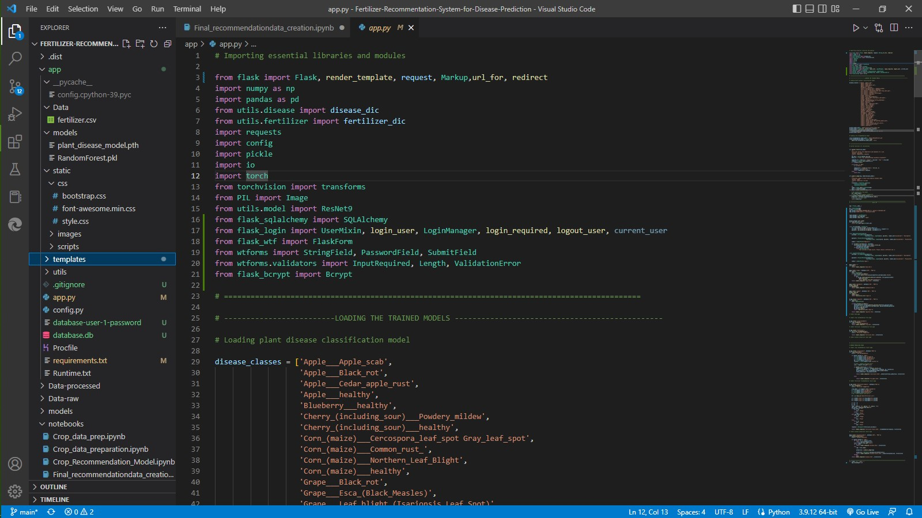

**5**

**Github Link :**<https://github.com/IBM-EPBL/IBM-Project-17508-1659672731.git>

**Project Demonstration Video Link :**

[**https://www.youtube.com/watch?v=frnCRmCW3Fc&ab_channel=GoberTechnologies**](https://www.youtube.com/watch?v=frnCRmCW3Fc&ab_channel=GoberTechnologies)

**5**